Year 11 Chemistry
AECHE

Unit 1
PART 1

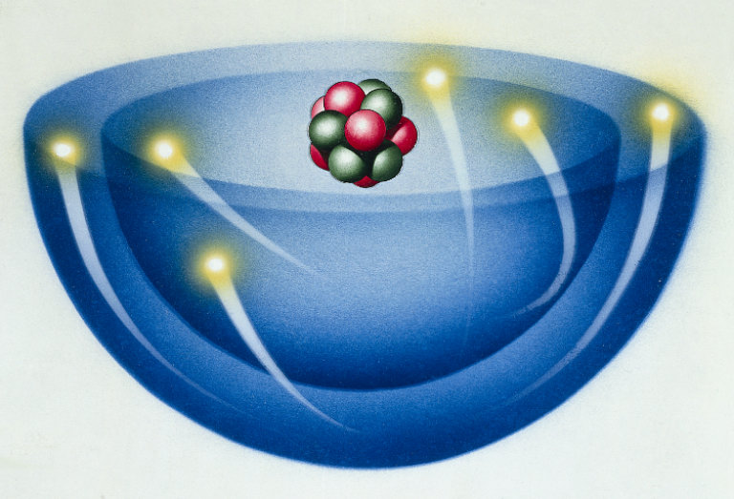

Properties and Structure of atoms

MATTER AND THE ATOM
Elements are represented by symbols.

- Elements are substances that are made up from only one type of atom.
- They are represented by symbols.
  - The symbols are
    - The first letter of their name Uranium = U
    - The first letter of their Latin, German or Greek name Potassium = K
    - The first two letters of their name Neon = Ne
    - The first two letters of their Latin, German or Greek name Iron = Fe

- The first letter is always a capital.
- If there are two letters, the second one is lower case. Cobalt = Co not CO
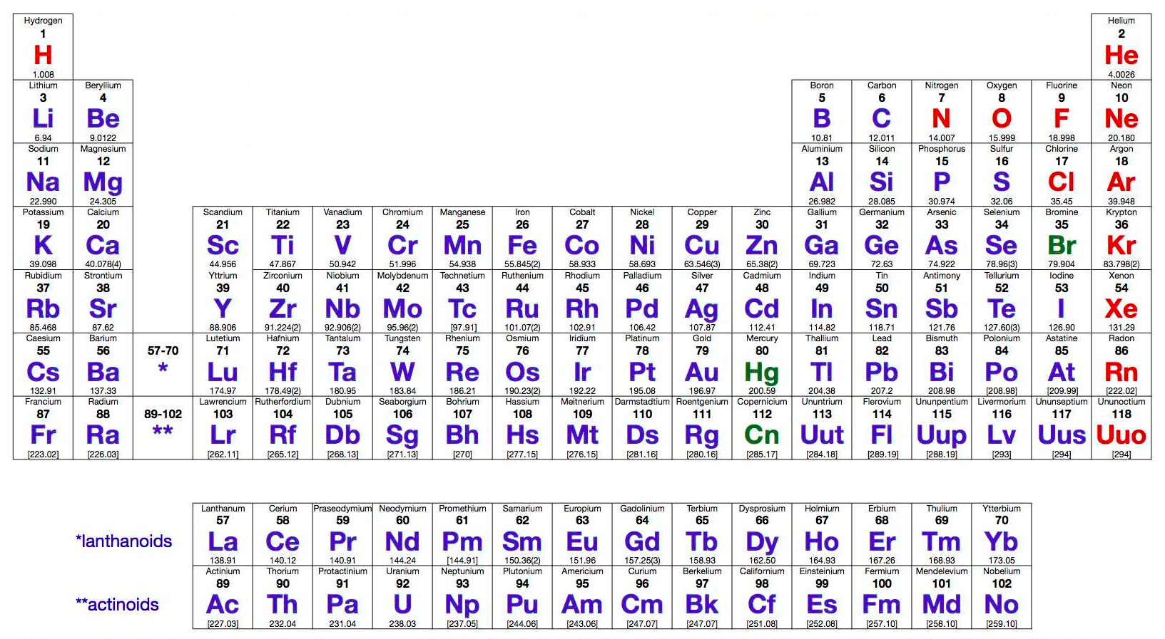

EC 1.7 p6
NC p3-6

History of the atom
Atoms can be modelled as a nucleus, surrounded by electrons in distinct energy levels, held together by electrostatic forces of attraction between the nucleus and electrons; the location of electrons within atoms can be represented using electron configuration.

- The word atom is derived from the Greek word “Atomos”, meaning indivisible.
- It is the smallest unit that defines each chemical element.
- Our current understanding of the structure of the atom has been developed over centuries of scientific research and discovery.
EC 2.1, 2.2 p 11
Democritus

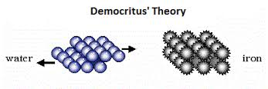
- Democritus’s model stated that matter consists of invisible particles called atoms and a void (empty space).
- Atoms are indestructible and unchangeable.
- They are homogenous, meaning they have no internal structure.
- His atomic model was solid.
- All atoms differ in size, shape, mass, position and arrangement.
- A void exists between them.
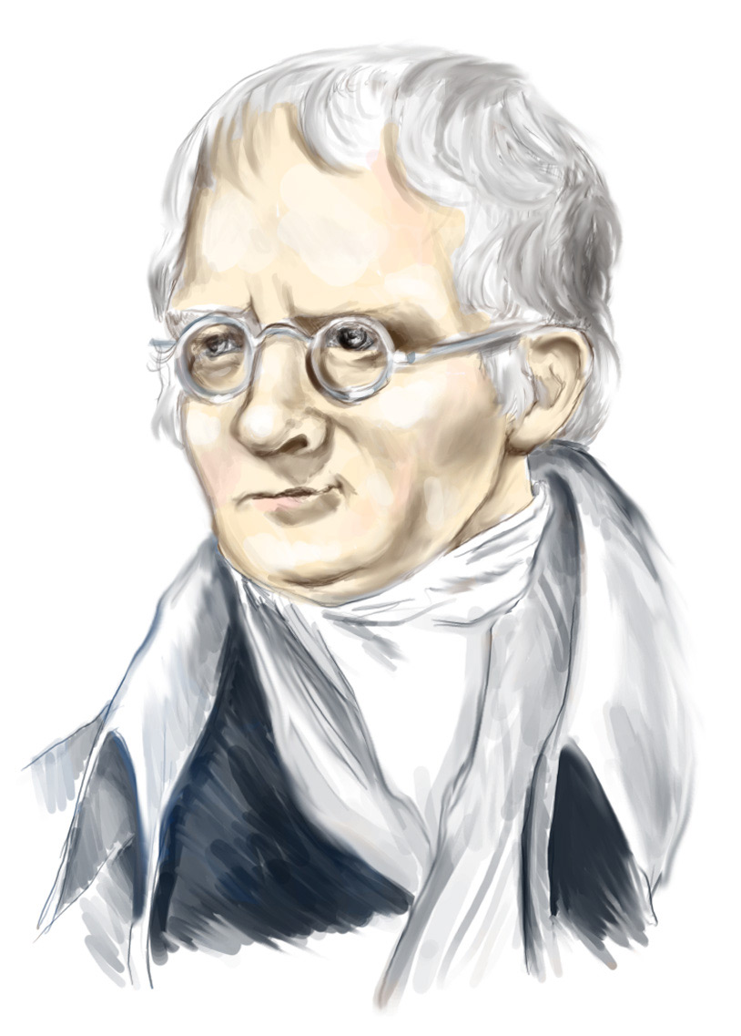
Dalton’s Atomic Theory

- In 1804, John Dalton first proposed the idea that tiny particles called atoms were the fundamental particles of nature. The main ideas (postulates) were:
  - All matter consists of tiny particles called atoms.
  - Atoms can neither be created nor destroyed.
Shared with Democritus
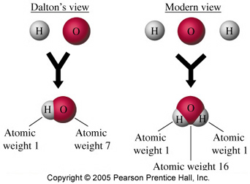
  - Atoms of an element are solid and indivisible and cannot be changed into atoms of any other elements.
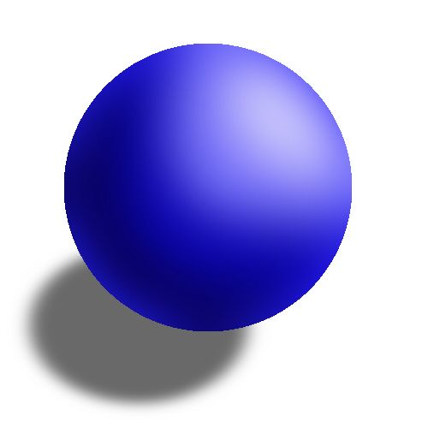
  - All atoms of the same element are identical in properties such as size, mass etc.
  - Atoms of one element differ in properties from atoms of other elements.
Dalton’s ideas
  - Chemical combination is the union of atoms of different elements, forming ‘compound-atoms’ (molecules).
  - In any compound the atoms are combined in constant, whole number ratios to each other.

EC 2.3 p12-3
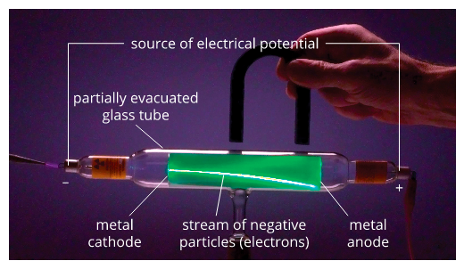
Joseph John Thompson
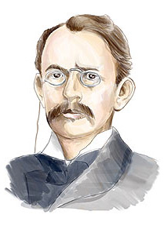
- Discovered the electron in 1987.

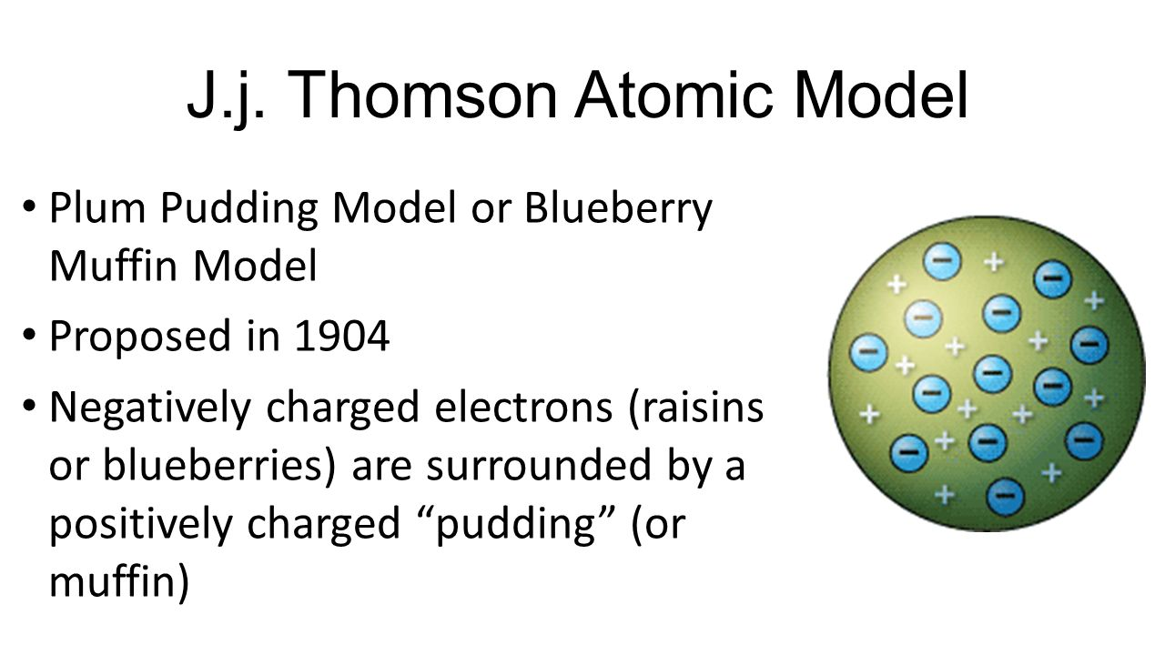
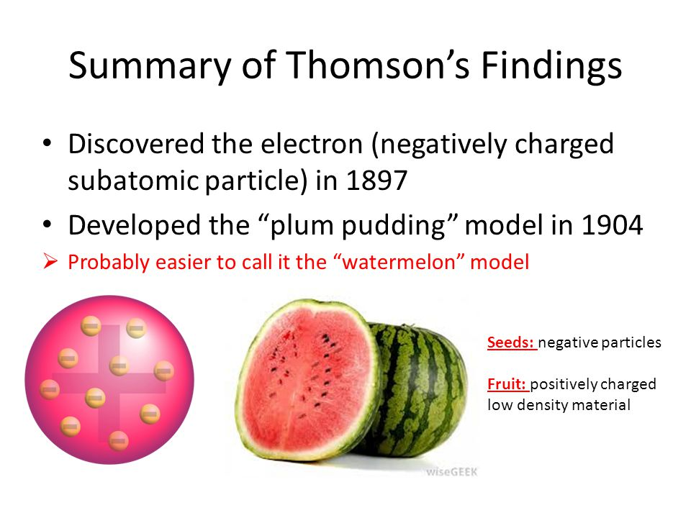
- Atoms are uniform spheres of positively charged matter.
- Electrons are embedded into the sphere like a plum-pudding or a watermelon.
- Developed the Plum-Pudding model.

EC 2.4, 2.5 p13-4


Ernest Rutherford

- Gold foil experiment – fired alpha particles at a thin foil of gold.
- Most passed straight through, indicating that an atom is not solid – it is mostly empty space.
- Some alpha particles were deflected straight back. He concluded that a small positive nucleus with most of the mass was at the centre.
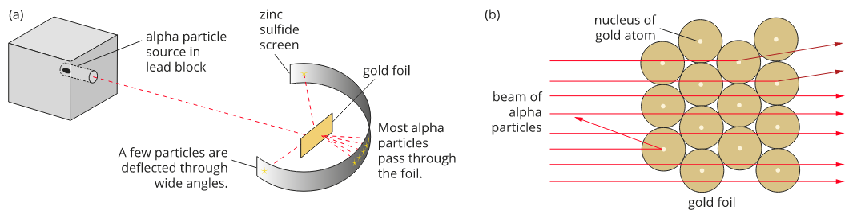

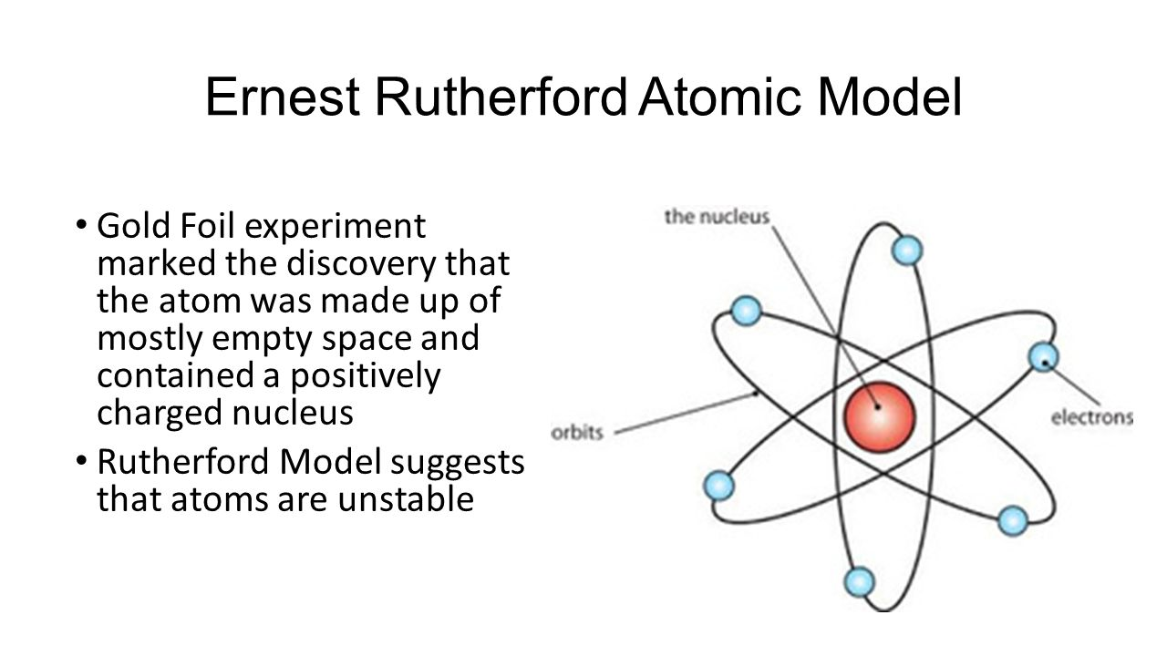

- Discovered the proton.
- Developed the Planetary Model in 1911 – electrons orbit the nucleus like planets around the Sun.

EC 2.6, 2.7 p14-5

Niels Bohr

- Electrons move around the nucleus in very specific orbits.
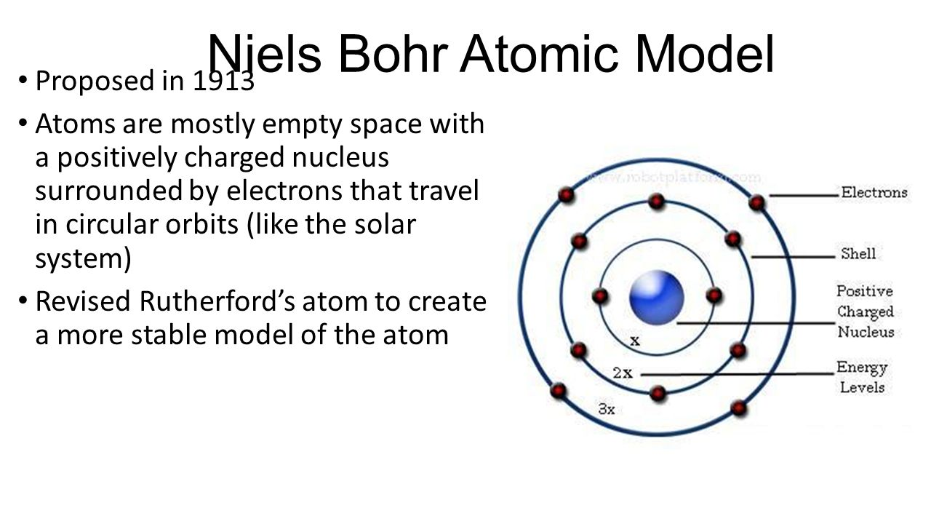
- Electrons can move from one orbit to another.

- Work carried out by these and other scientists led to understanding that atoms consist of protons, neutron and electrons. Their discoveries led to a nuclear model of the atom and the following ideas:

- Atoms consist of two regions – a small dense nucleus surrounded by a cloud of electrons.
- The nucleus is positively charged and contains protons and neutrons. The very large majority of the mass of an atom is contained in the nucleus.
- The electrons are negatively charged and have a very small mass. They move rapidly in the region of space around the nucleus creating an effect of an electron cloud. This electron cloud makes up nearly all the volume of the atom.
- Atoms are electrically neutral. Hence the number of protons is equal to the number of electrons.
- Electrons are attracted to the nucleus by electrostatic forces.

EC 2.8 p16-7

The Structure of the Atom

- The three fundamental particles which make up atoms include: protons, neutrons and electrons.

 | Relative  Mass | Actual Mass | Relative  Charge | Actual Charge
Proton | 1 | 1.673 x 10⁻²⁷ kg | +1 | +1.602 x 10⁻¹⁹ C
Neutron | 1 | 1.675 x 10⁻²⁷ kg | 0 | 0
Electrons | $$\frac{1}{1836}$$ | 9.110 x 10⁻³¹ kg | -1 | -1.602 x 10⁻¹⁹ C

- Protons and neutrons have approximately the same mass.
- Electrons have a much smaller mass, about 1/2000th the mass of protons and neutrons.
- Protons and electrons have equal but opposite charges - protons have a positive charge and electrons have a negative charge.
- Neutrons are uncharged.

NC 1.1 p104

A Model of the Atom

- From many experiments, particularly those of Lord Rutherford early this century, the atom is believed to have a relatively small, dense nucleus consisting of protons and neutrons.
- The electrons are located within a region called the electron cloud which constitutes the atom’s volume. It is mostly space.
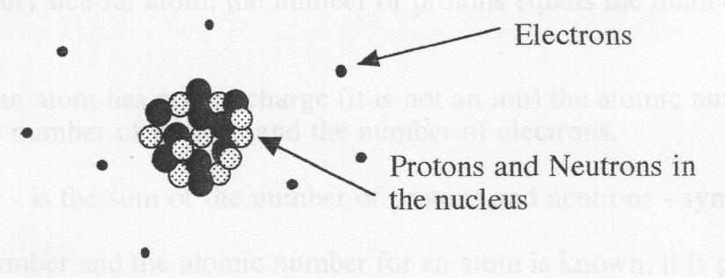

- Further development of the atom suggested that electrons were confined to specific orbits.
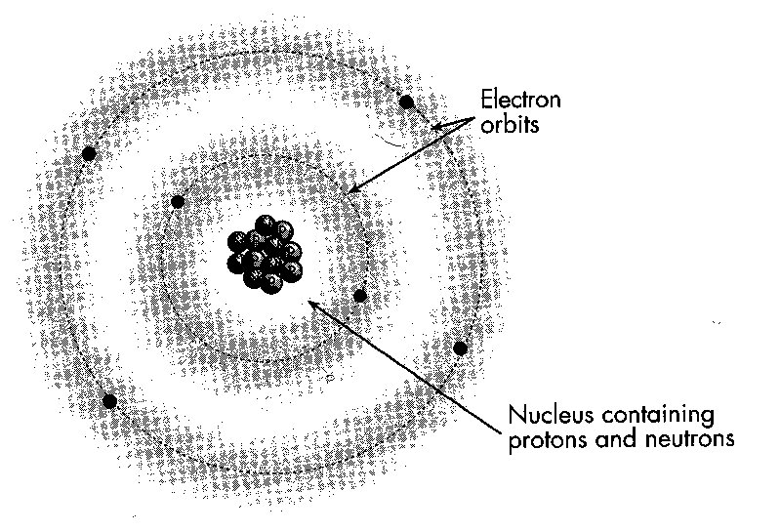

The Structure of the Nucleus

- The central part of the atom that contains the protons and neutrons has a positive charge equal to the number of electrons.
- It is exceedingly small when compared with an atom (pea in a football field).
- It contains 99.9% of the mass of an atom - due to the relatively larger masses of the protons and neutrons when compared to the masses of the electrons.
- It is very dense - due to its large mass and small volume

The Arrangement of the Electrons around the Nucleus

- Electrons move through a relatively large space outside the nucleus.
- Kept moving around the nucleus by attractive electrostatic forces between the positively charged nucleus and the negatively charged electrons.
- In a neutral or uncharged atom, the number of electrons equals the number of proton

EC 2.9 p17

How Atoms Differ

- Atoms can differ in atomic number and mass number:
  - Atomic Number - is the number of protons in the nucleus of an atom - symbol (Z).
In an electrically neutral atom, the number of protons equals the number of electrons.
If an atom has no net charge (it is not an ion) the atomic number represents the number of protons and the number of electrons.

- Mass Number - is the sum of the number of protons and neutrons - symbol (A).
If the mass number and the atomic number for an atom is known, it is possible to work out the number of neutrons in the nucleus of that atom:

- Mass Number = Atomic Number + Number of Neutrons
A = Z + Number of Neutrons

- The convention used to identify the structure of an atom (also called a nuclide) is:
where: A is the mass number
X is the element symbol
Z is the atomic number

PROBLEM SET : 1 Answers p 39

- What is the difference between the atomic number and mass number of an atom?

- Give the mass number and atomic number of the following isotopes. (Use your periodic table.)
a. nitrogen-14,
b. iodine-127,
c. sodium-23,
d. argon-40,

3. Determine the number of protons, neutrons and electrons contained in one atom of the following:
a. lithium-7,
b. chlorine-35,
c. carbon-12,
d. chromium-52,
4. Use standard notation to write the symbol for neutral isotopes of atoms having a composition shown in the table below:

Isotope | A | B | C | D
Number of Protons | 2 | 84 | 32 | 9
Number of Neutrons | 2 | 125 | 40 | 10
Standard Notation

5. Complete the table for each of the ions listed:

 | A | B | C | D | E | F | G
Ion | Mg²⁺ | S²⁻ | Cl⁻ | I⁻ | N²⁻ | Fe²⁺ | Fe³⁺
Number of Protons

Number of Electrons

NC 1.1 p105-6
EC 1.8, 1.9 p6-7
Forces inside the atom

- The attraction between the positive nucleus (because of protons) and the negative electrons keeps the atom together and is called electrostatic attraction.

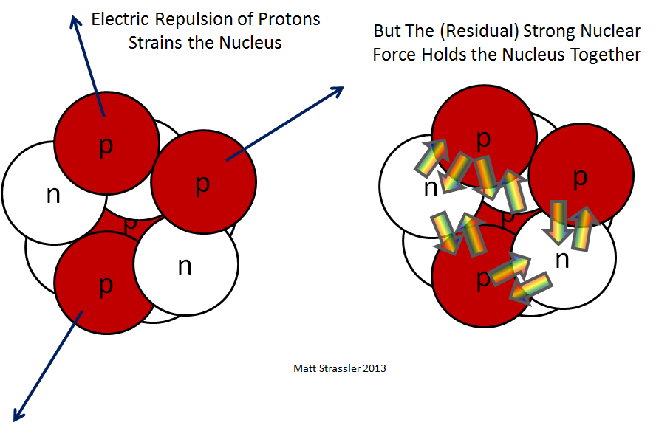
- The repulsive force in the nucleus between positive protons is called electrostatic repulsion.

- Another type of force is present in the nucleus and acts between all particles in the nucleus, regardless of charge. The protons and neutrons are held together in a nucleus of an atom by this strong nuclear force.
- Gets its name by being the strongest attractive force.
- It is 137 times more powerful than electromagnetic (which cannot hold neutrons to protons because neutrons are not charged).
- It is 6,000 billion billion billion billion (6 followed by 39 zeroes) times more powerful than gravity (which has almost no effect at atomic scales).
- It only operates at EXTREMELY small distances. These distances are on the order of a 1000th millionth millionth of a meter (10 to the power of -15).

- In the nucleus there is a delicate balance of the strong nuclear force pulling the atoms in to each other and the electrostatic force which pushes protons apart.
- It is only when they are so close together does the attractive strong nuclear force overpower the electrostatic force.

NC 1.1 p107
NC QS 1.1 p108

Isotopes
Isotopes of an element have the same electron configuration and possess similar chemical properties but have different physical properties.

- All atoms of a given element have the same number of protons but the number of neutrons may vary.
- Hence, different forms of an element may have a different mass number (A).
- These different forms of an element are called isotopes.

- Examples of isotopes include:
; ;

- Each are isotopes of oxygen, each has the same atomic number (hence same element), but each has different mass numbers.

- Three isotopes of hydrogen are:
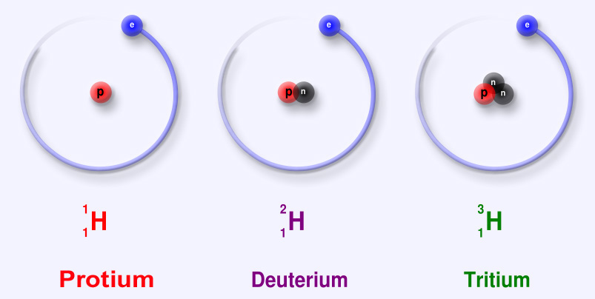

- Isotopes have the same number of protons so will have the same number of electrons.
- Since electrons determine chemical reactions, isotopes will have very similar chemical properties.
- Physical properties such as mass, density, boiling points, melting points, radioactivity can be different due to the different numbers of neutrons.

NC 1.2 p108-9

NC 1.5 p113 (Elemental Carbon)
NC p22-6

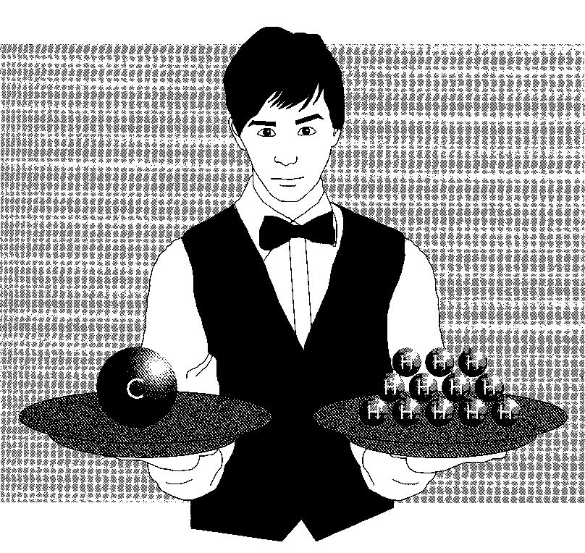
Relative Atomic Mass of Atoms and Isotopes
The relative atomic mass (atomic weight), A_{r} is the ratio of the average mass of the atom to 1/12 the mass of an atom of ¹²C; relative atomic masses of the elements are calculated from their isotopic composition

- Atoms are so small so it is convenient to describe the mass of an atom by comparing its mass with those of other atoms.

- Relative atomic mass (A_{r}) is the mass of an atom of that element compared with 1/12 the mass of an atom of carbon-12 which is taken to be exactly twelve (12.0).
- It has no units because it is a ratio.

- The mass of one carbon-12 is equal to the mass of twelve hydrogen-1 atoms.

- Three He-4 atoms would have the same mass as one C-12 atom.
Four C-12 atoms would have the same mass as Ti-48 atom.
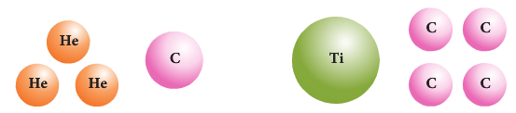
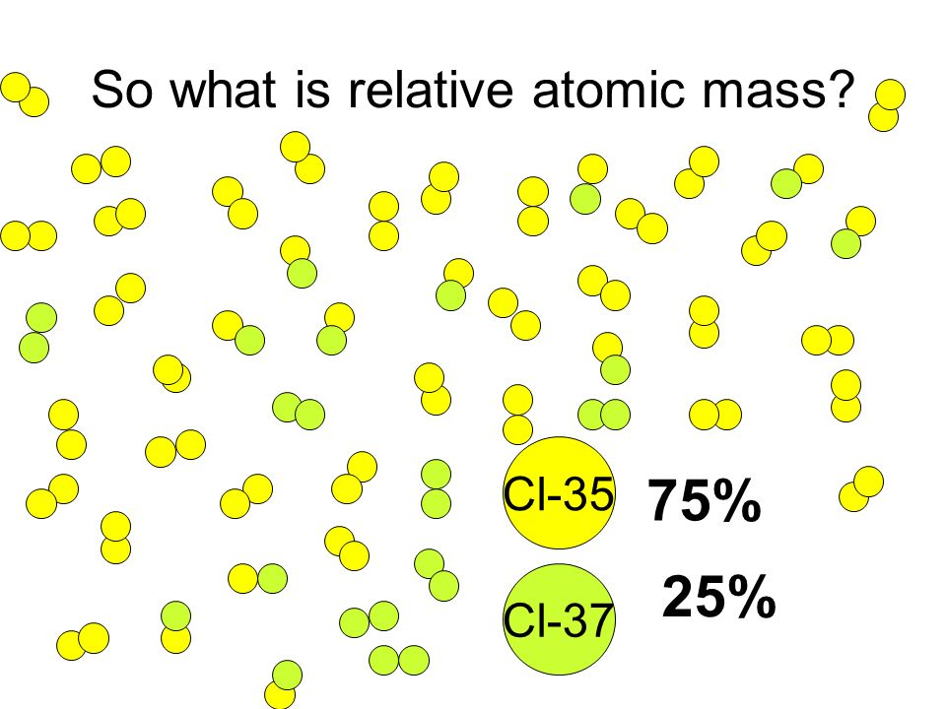
- The relative atomic mass of an element depends on the masses and proportions of each isotope in nature.
- They are usually not whole numbers. Chlorine has an overall relative atomic mass of 35.5. This is made up from 25% of Cl-37 and 75% of Cl-37.

- Isotopes have different masses since they contain different numbers of neutrons in the nucleus.
  - Carbon-12, carbon-13 and carbon-14 contain 6, 7 and 8 neutrons respectively.
  - Pure C-12 has A_{r} = 12.00.
  - Since a sample of C is made up from four different isotopes it’s A_{r} = 12.01

Example 1 (atom): The relative atomic mass (A_{r}) for carbon is taken to be exactly 12.0. If the magnesium atom is approximately twice that of the carbon atom, what would be the likely A_{r} for Mg? (Answers p 39)

Example 2 (atom): If the mass of 3 helium atoms is exactly the same as 1 carbon atom, what is the A_{r} for helium?

Example 3 (isotope):
A natural sample of thallium consists of two isotopes. One isotope has an Ar (relative atomic mass) of 203.0 and makes up 29.50 % of the thallium atoms. The remaining 70.50 % of the atoms have an Ar of 205.0. Determine the average relative atomic mass of a natural sample of thallium.

Example 4 (isotope):
Naturally occurring bromine consists of two isotopes of relative atomic masses 78.9 and 80.9. If naturally occurring bromine consists of 50.5% bromine-78.9 and 49.5% bromine-80.9, calculate the relative atomic mass of naturally occurring bromine.

- This explains where the mass numbers on your periodic table come from

PROBLEM SET : 2 Answers p 40

Helium-3; ${}_{2}^{3}{He}$ and helium-4; ${}_{2}^{4}{He}$, are two isotopes of helium. How are the isotopes similar and how are they different?

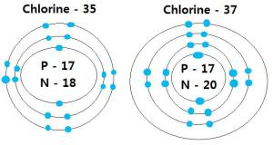
Naturally occurring chlorine consists of about 75% chlorine-35, which has a relative atomic mass of 35.0, and 25% chlorine-37, with a relative atomic mass of 37.0. Calculate the approximate relative atomic mass of naturally occurring chlorine.

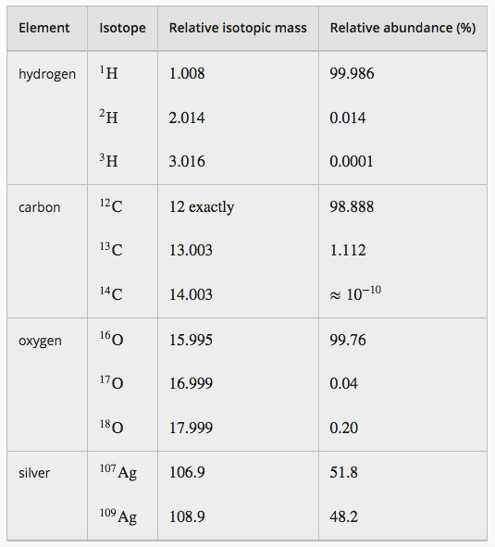

NC 1.3 p109-10
NC QS 1.2 p110
EC 1.10 p7-8

Mass Spectrometry
Mass spectrometry involves the ionisation of substances and the separation and detection of the resulting ions; the spectra which are generated can be analysed to determine the isotopic composition of elements and interpreted to determine relative atomic mass.

- Mass spectrometry is a tool analytical chemists use to work out:
  - the abundance of isotopes in a sample of an element.
  - the relative atomic mass of the element.
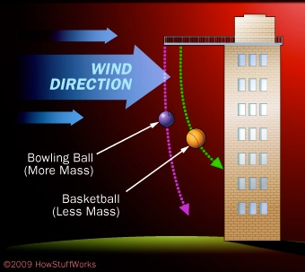
  - the amount and types of chemicals in a substance.

- In order to understand how mass spectrometry works, first think about how objects with different masses move and are deflected.
- The lighter the object is the it more it will move and the more it will be deflected. This applies to atoms and ions as well as whole objects.

- In a mass spectrometer the same thing is happening, except the balls are atoms or molecules and the wind is an electric or magnetic field.

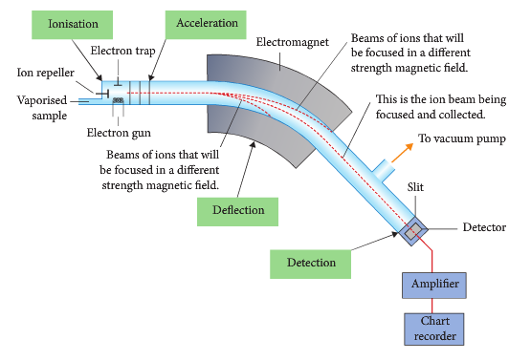
- The sequence is :
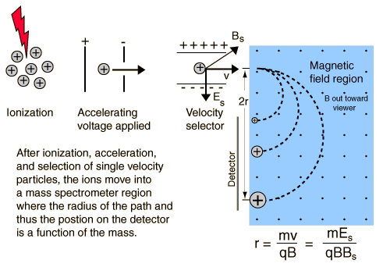
  - Stage 1: Ionisation
    - The sample is bombarded with high energy electrons or ultraviolet light.
    - The atom is then ionised by knocking one or more electrons off to give a positive ion.
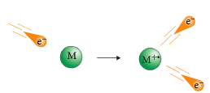
    - All atoms can be turned into positive charged ions, even things which you would normally expect to form negative ions (chlorine, for example) or never form ions at all (argon, for example).
    - Mass spectrometers always work with positive ions.
    - Different isotopes will now have different ions with different masses, even if they have the same amount of protons.

- Stage 2: Acceleration

- The ions are accelerated through an electric field so that they all have the same kinetic energy.
- One grid is positively charged and repels the ions. The other is negatively charged and attracts the ions.
- As both grids are moving the particles in the same direction they move very rapidly towards the negatively charged grid, which has lots of tiny holes.


- Stage 3: Deflection
- The ions pass through the holes at different speeds, the lighter ions travelling faster than the heavier ones. When a charged particle moves, it creates its own magnetic field and that is what the next and main part of the process takes advantage of.
- The ions are then deflected by a magnetic field according to their masses. The lighter they are, the more they are deflected.
- How much an ion’s path will bend will depend on two factors: the particle’s mass and the particle’s charge.
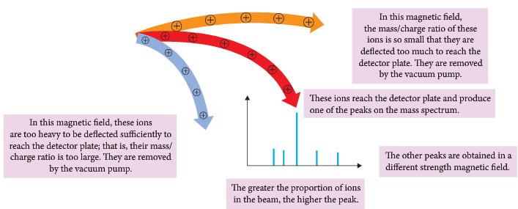

PROBLEM: 3 Answers p 38
Circle the factor that will cause the ion’s path to curve more:

Low mass High mass

Low charge High charge

- These two factors are combined into a value called a mass-to-charge ratio (m/z).
- For example, if an ion has a mass of 18 units and a charge of 1+, its m/z value is 18.
- If an ion has a mass of 36 units and a 2+ charge, its m/z value is also 18.
- Most of the ions moving from the ionization chamber to the mass analyser have lost a single electron, so they have a charge of 1+.
- That means the m/z value of most ions passing through a mass spectrometer is the same as the mass of the ion.

- The overall result is that each ion follows a path dependent on its mass.
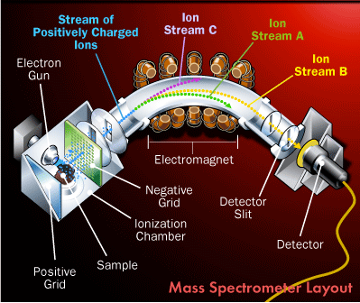
PROBLEM: 4 Answer p 40

List the three ion streams below in order of lightest to heaviest:

- One of the streams will curve so that it passes through the mass analyser so that it hits the detector at the back.
- The other two streams hit the side and are neutralised.

- Stage 4: Detection

- To analyse all of the ions, the magnetic field strength is adjusted until all streams have hit the detector.
- A computer is then used to analyse the data collected by the detector in a graph called a mass spectrum.
- The mass is plotted on the x-axis and intensity (how many ions of a given mass are detected) is plotted on the y-axis.
- The beam of ions passing through the machine is detected electrically.
- This information is transformed into graphical; form called a mass spectrum.
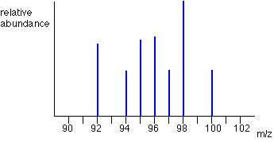

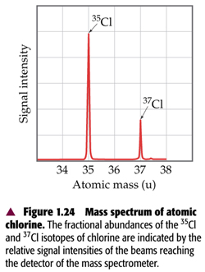
- The diagram show the mass spectrum for a sample of chlorine.

PROBLEM: 5 Answers p 40
- What do you notice about the relative intensities of each isotope?

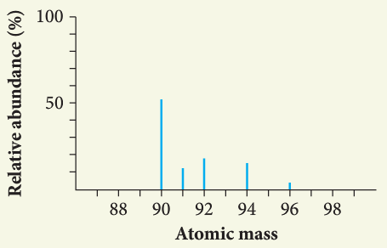
- Identify the isotopes present in this element.
Show the relative abundance of the isotopes.
Identify the element by calculating the relative atomic mass.

Uses of Mass Spectrometry

- MS is often coupled with another process that allows us to separate out lots of different compounds within a substance.
- A common one is Gas Chromatography.

  - Drug testing – testing urine samples to identify illicit substances
  - Astronomers – determining the elements and isotopes of solar winds
  - Environmental scientists – detecting toxins in contaminated fish, types of particles in atmosphere
  - Biologists – identify different carbohydrates, proteins and nucleic acids, how HIV assembles itself in a host cell
  - Anaesthetist – measuring CO2 exhaled/O2 consumed to ensure patient’s cells are remaining healthy
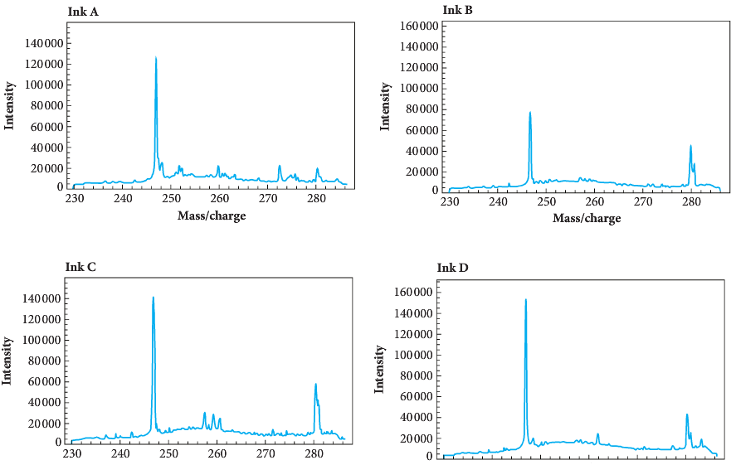

  - Geologists – locate oil deposits, carbon dating.

- A handwritten will has been found by two siblings fighting over the contents. The brother claims that the estate was supposed to be shared equally. This will states that everything will go to the sister. A forensic chemist assisting the police gives the following information:
  - Pens A and B were found in the parents’ house.
  - Pens A and C were discovered in the daughter’s house.
  - Ink analysed from the will shows a m/c peak at 247 with an intensity of 80 000.
  - A section of the will that names the daughter as the sole recipient shows ink with a m/c peak at 247 with a peak of 140 000.
- What do you conclude? (Answer p 39)

NC 1.10 p131-2
NC QS 1.7 p133
NC p9-15
EC 1.11 p8
Atoms can be modelled as a nucleus, surrounded by electrons in distinct energy levels, held together by electrostatic forces of attraction between the nucleus and electrons; the location of electrons within atoms can be represented using electron configuration.

ELECTRON CONFIGURATIONS

Electron Arrangement in Atoms

- Electrons exist regions of space around the nucleus that are referred to as shells
– called 1, 2, 3, 4 … or K, L, M, N …
- Electrons in different shells have different energies.

Shell 1 = K

Shell 2 = L
nucleus
Shell 3 = M

Shell 4 = N

- An electron configuration describes the arrangement of electrons surrounding the nucleus of an atom.
- It indicates how many electrons are in each energy level or shell.

- An electron configuration of an element expressed as 2, 8, 1 suggests
  - it has three shells
  - 2 in the first shell, 8 in the second shell, 1 in the third shell
  - it has 11 e⁻ in total
  - the atom is sodium (11 e⁻, 1 in the outer shell)

- Within each shell there are subshells (or orbitals) called s, p, d, f subshells.
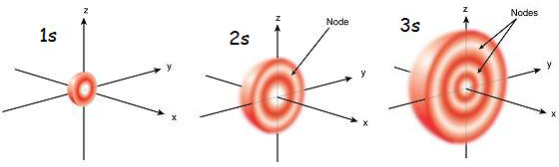

s-orbital shape
(spherical)

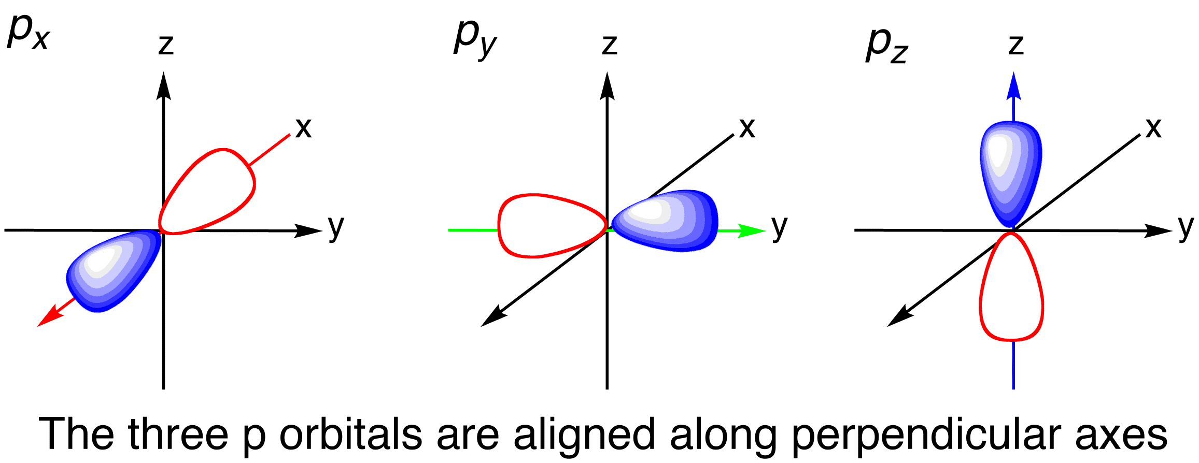

p-orbital shape
(double teardrop)

- Each s orbital can contain 2 e⁻.
- Each p orbital can contain 6 e⁻.
- Each d orbital can contain 10 e⁻.
- Each f orbital can contain 14 e⁻.

- Electron configuration can be indicated using two methods eg. Magnesium with 12 electrons:

  - s p notation 1s² 2s²2p⁶ 3s² electrons

energy level orbital

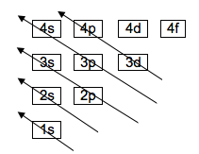
  - Abbreviated method 2,8,2

- Electrons fill shells in the methods described by the table (however we are only going to work with element 1-20).

- That is, the order of filling is 1s, 2s, 2p, 3s, 3p, 4s, 3d, 4p, …etc.

- If an atom has 1 e⁻ it starts to fill the 1s subshell.

# of e⁻‘s | s p notation | e⁻ configuration | element
1 | 1s¹ | 1 | H

- If an atom has 2 e⁻‘s it fills the 1s subshell.

# of e⁻‘s | s p notation | e⁻ configuration | element
2 | 1s² | 2 | He

- Now, shell 1 is filled and shell 2 starts to fill.

- If an atom has 3 e⁻‘s it fills the 1s subshell, then starts to fill the 2s subshell.

# of e⁻‘s | s p notation | e⁻ configuration | element
3 | 1s² 2s¹ | 2, 1 | Li

- If an atom has 4 e⁻‘s, it fills the 1s subshell, then fills the 2s subshell.

# of e⁻‘s | s p notation | e⁻ configuration | element
4 | 1s² 2s² | 2, 2 | Be

- The next shell to be filled will be the 2p subshell.

- If an atom has 5 e⁻‘s the 1s subshell is full, the 2s subshell is full, then starts to fill the 2p subshell.

# of e⁻‘s | s p notation | e⁻ configuration | element
5 | 1s² 2s² 2p¹ | 2, 3 | B
Complete for the rest of row 2 elements.

# of e⁻‘s | s p notation | e⁻ configuration | element
6 | 1s² 2s² 2p² | 2, 4
7 | 1s² 2s² 2p
8 | 1s² 2s² 2p
9 | 1s² 2s² 2p
10 | 1s² 2s² 2p

- Now, shell 2 is filled and shell 3 starts to fill.

- If an atom has 11 e⁻‘s the 1s subshell is full, the 2s subshell is full, the 2p subshell is full, then starts to fill the 3s subshell.

# of e⁻‘s | s p notation | e⁻ configuration | element
11 | 1s² 2s² 2p⁶ 3s¹ | 2, 8, 1 | Na
12 | 1s² 2s² 2p⁶ 3s² | 2, 8, 2 | Mg

The 3s subshell is now full and the next subshell to fill is the 3p.

# of e⁻‘s | s p notation | e⁻ configuration | element
13 | 1s² 2s² 2p⁶ 3s² 3p¹ | 2, 8, 3 | Al
14 | 1s² 2s² 2p⁶ 3s² 3p² | 2, 8, 4 | Si

Complete for the rest of row 3 elements.

# of e⁻‘s | s p notation | e⁻ configuration | element
15 | 1s² 2s² 2p⁶ 3s² 3p³ | 2, 8, 5 | P
16 | 1s² 2s² 2p⁶ 3s² 3p
17 | 1s² 2s² 2p⁶ 3s² 3p
18 | 1s² 2s² 2p⁶ 3s² 3p

- The next shell to fill is the 4s subshell.

# of e⁻‘s | s p notation | e⁻ configuration | element
19 | 1s² 2s² 2p⁶ 3s² 3p⁶ 4s¹ | 2, 8, 8, 1 | K
20 | 1s² 2s² 2p⁶ 3s² 3p⁶ 4s² | 2, 8, 8, 2 | Ca

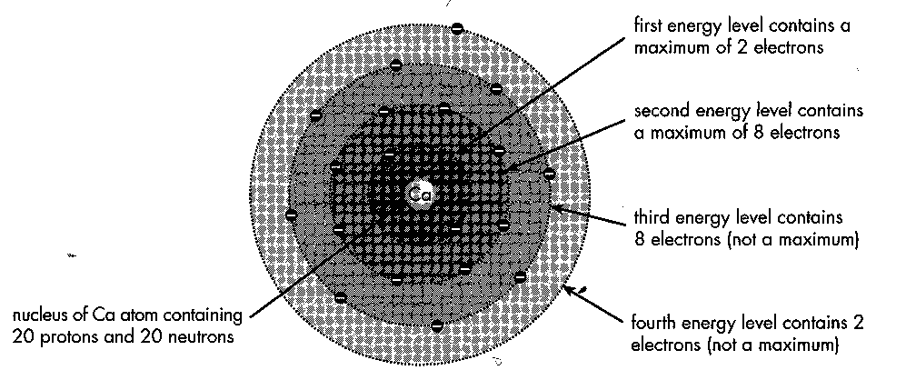
①
①
①
①
①
①
①
①
①
①
①
①
①
①
①
①
①
①
①
①
Ca

- In Year 11 Chemistry, we only need to know the electron configuration up to element 20 – calcium.

- What about ions?

Mg²⁺ (how many e⁻?)
# of e⁻‘s | s p notation | e⁻ configuration | same as

S²⁻ (how many e⁻?)
# of e⁻‘s | s p notation | e⁻ configuration | same as

EC 7.3, 7.4 p48

Questions: 6 Answers p 40
  - What is the maximum number of electrons that can be located in the following sublevels?
2s 2p 3s 3p
  - Draw the electron arrangement for (a) carbon and (b) sulphur?

  - Write the electron configuration (both methods) for the following:
- Helium
- Aluminium
- Neon
- Nitrogen
- Carbon
- Potassium

  - From these electron configurations identify the name, period and group of the element.
 | Electron configuration |  | Element name | Period | Group
a. | 1s² 2s²2p⁶ 3s¹ | 2,8,1
b. | 1s² 2s²2p⁴ | 2,6
c. | 1s² 2s²2p⁶ 3s²3p² | 2,8,4
d. | 1s² 2s²2p⁶ 3s²3p⁶ | 2,8,8

  - Consider a neutral atom with the electron configuration 1s² 2s²2p⁶ 3s¹
- Identify the element.
- What would be its ground state electron configuration?
- What would happen if the atom changed its configuration from its excited state to the ground state?

NC 1.6 p113-8
NC QS 1.4 p119

Flame tests and atomic absorption spectroscopy (AAS) are analytical techniques that can be used to identify elements; these methods rely on electron transfer between atomic energy levels and are shown by line spectra.

Using Energy Levels To Identify Elements

- The electron energy levels of every element are unique to that element. This information can be used to detect the presence of different elements in a number of ways.

Movement of electrons
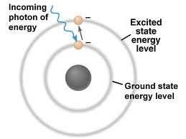
- When all the electrons in an atom are in their lowest possible energy level, the electrons are said to be in the ground state.
- When an atom absorbs energy (heat or light) the electrons can move up to a higher energy level.
  - As an atom can have multiple energy levels, an electron can move up one, two or even more energy levels.
  - An atom with electrons in these upper energy levels is said to be in an exited state.
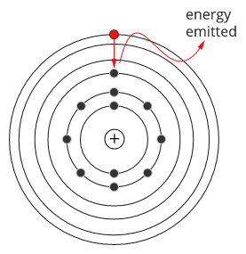
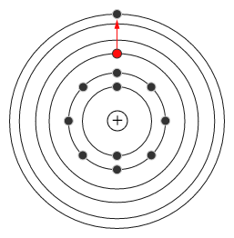

- Once an electron moves to a higher-energy orbit, it eventually wants to return to the ground state. When it does, it releases its energy as a photon -- a particle of light.
- Energy is related to the wavelength of the light produced, so this light has a specific wavelength.
- When energy is added to a specific element, e.g. magnesium, all the electrons of the different atoms will move between the same energy levels and emit the same wavelength light.

- You see atoms releasing energy as photons all the time.
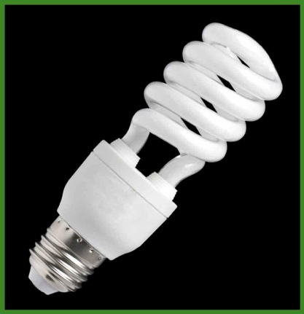
  - The heating element in a toaster turns a bright red colour. This is caused by atoms, excited by heat, releasing red photons.
  - A TV screen emits different colours of light. From phosphor atoms, excited by high-speed electrons.
  - Anything that produces light -- fluorescent lights, gas lanterns, incandescent bulbs -- does it through the action of electrons changing orbits and releasing photons.
- Some element ions give a characteristic colour when placed into a flame of a Bunsen burner. These different colours can be used to identify different cations (positive ions).

Flame Tests

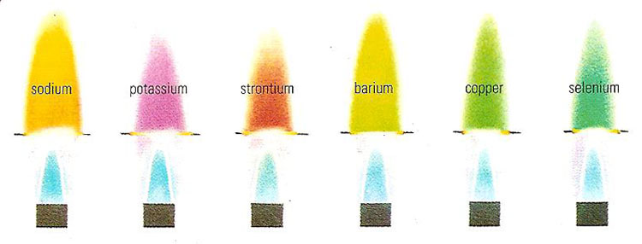
- A flame test is an analytical procedure used to detect the presence of certain elements, usually metal ions, based on the element’s emission spectrum.

- Separate atoms present in the flames can only emit light due to electrons moving from a higher energy level (excited state) to a lower energy level.
- The energy difference between the energy levels is emitted as light of a specific frequency and is unique to that element.
- The flame then takes on the colour of the chemical being put into the flame.

- Flame tests are qualitative not quantitative. This means that we can only determine whether or not an element is present, not how much (or the quantity) present.

Emission spectroscopy
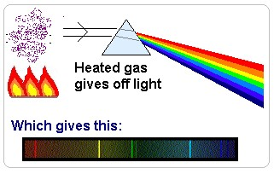
- Atomic emission spectroscopy (AES) is a method of chemical analysis that uses the intensity of light emitted from a flame, plasma, arc, or spark at a particular wavelength to determine the quantity of an element in a sample.
- When a sample of gaseous atoms of an element at low pressure is subjected to an input of energy, such as from a flame, the atoms are themselves found to emit electromagnetic radiation.
- This emitted light can be analysed and this process is called spectroscopy.

- On passing through a very thin slit and then through a prism the light (electromagnetic radiation) emitted by the excited atoms is separated into its component frequencies (wavelengths).

- A spectroscope is a device used to take the light emitted and separate it in its component wavelengths to produce an emission spectrum.

- The excited atoms emit only certain frequencies (wavelengths), and when these are placed as discreet lines along a frequency scale an atomic emission spectrum is formed.
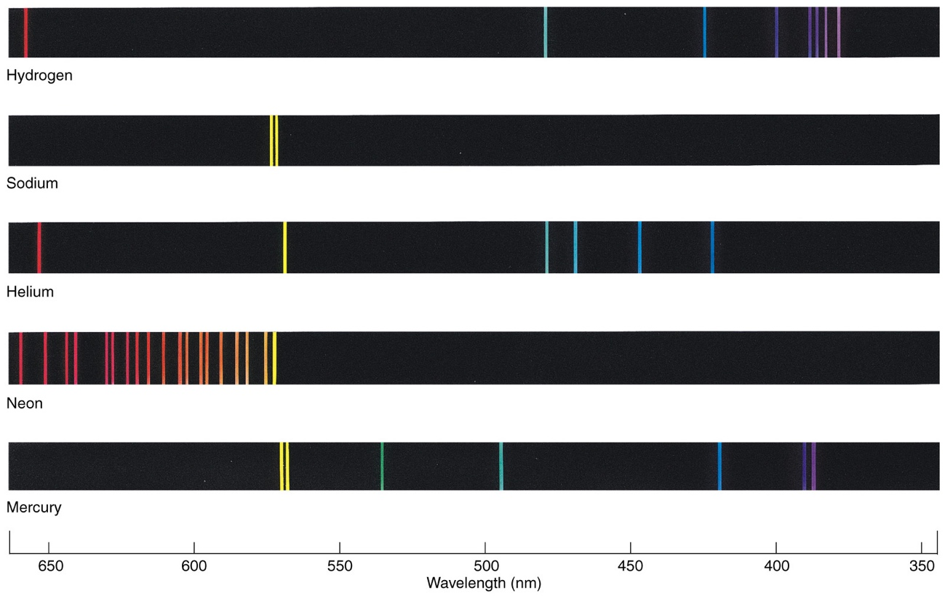
The spectral lines in the visible region of the atomic emission spectrum of elements are shown below.

- Spectral lines exist in series in the different regions (infra-red, visible and ultra-violet) of the spectrum of electromagnetic radiation.
- The spectral lines in a series get closer together with increasing frequency.
- Each element has its own unique atomic emission spectrum.
- This is a way of identifying elements.

How will you use this technique to identify an unknown element? Answer p 40
______________________________________________________________________________________________________________________________________________________________________________________________________________________________
- These spectra can be used to determine the composition of stars.

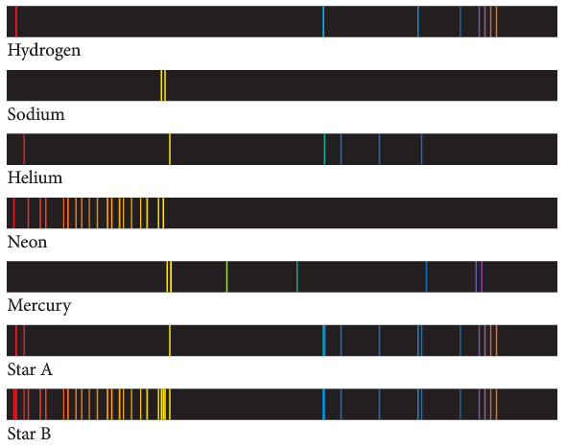

Here's what happens when you heat up a hydrogen atom
- When a gaseous hydrogen atom in its ground state is excited by an input of energy, its electron is 'promoted' from the lowest energy level to one of higher energy. The atom does not remain excited but re-emits energy as electromagnetic radiation. This is as a result of an electron 'falling' from a higher energy level to one of lower energy. This electron transition results in the release of a photon from the atom of an amount of energy (E = hf) equal to the difference in energy of the electronic energy levels involved in the transition. In a sample of gaseous hydrogen where there are many trillions of atoms all of the possible electron transitions from higher to lower energy levels will take place many times. A prism can now be used to separate the emitted electromagnetic radiation into its component frequencies (wavelengths or energies). These are then represented as spectral lines along an increasing frequency (or wavelength) scale to form an atomic emission spectrum.

NC 1.8 p123-5
NC QS 1.6 p126
Atomic Absorption Spectroscopy (AAS)

- Spectroscopy: The study of the interaction of electromagnetic radiation with matter.

- When vaporised, different elements absorb light of specific frequencies.
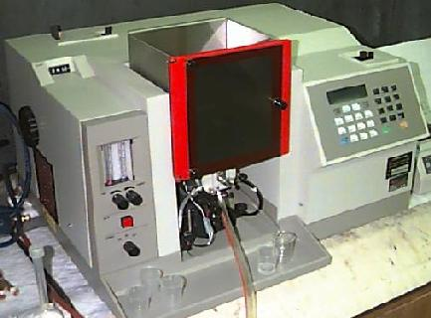
- Atomic absorption spectroscopy (AAS): An analytical technique used to identify the presence and concentration of substances by analysing the spectrum produced when a substance is vaporised and absorbs certain frequencies of light.
- AAS is used particularly for detecting the concentrations of metal ions in solutions.
- AAS is performed using an atomic absorption spectrometer.

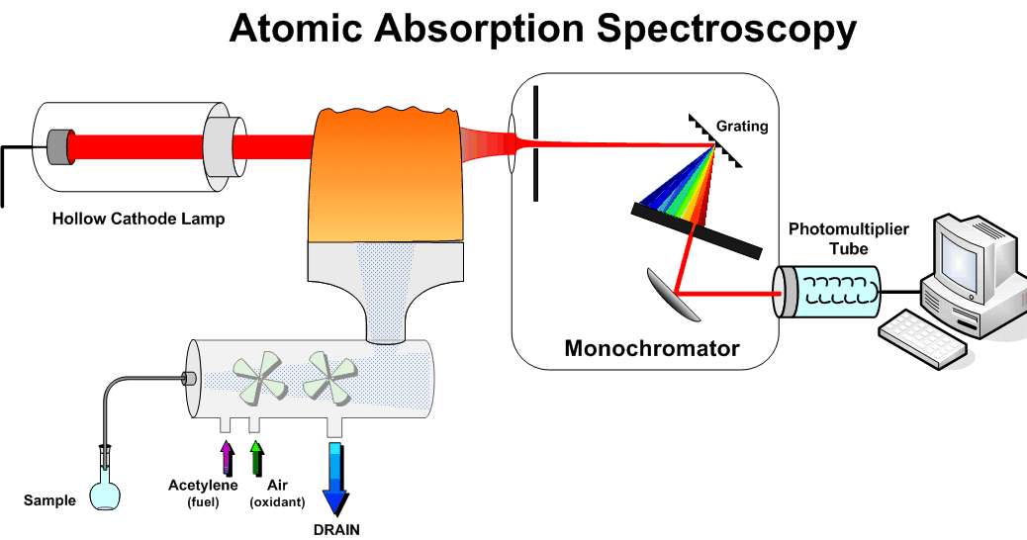

- To determine the concentration of a certain metal ion in a sample, the following steps occur within an atomic absorption spectrometer:
  - The element being analysed is determined. If there are multiple elements present in a substance, like paint, all the elements would absorb normal light making the process useless. We need to focus on one element.
  - The lamp for this process must be the same as the element being tested.
  - A hollow cathode lamp, with the cathode made of the metal to be tested for, emits light of a certain frequency.
  - The light produced by the lamp is passed through the sample to be tested vaporised in a flame changing the substance it contains into atoms.
  - The degree of light absorption is proportional to the concentration of the metal in the sample.
  - Only the element being tested for will absorb the light of the lamp because it has the same energy levels as the atoms that emitted the light from the lamp. Other elements in the vaporised form will not absorb this light. Why not? _____________________________________________________________________
_____________________________________________________________________
_____________________________________________________________________
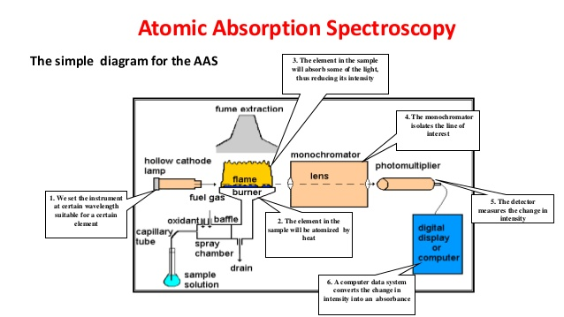
  - The light passes through the sample and is focused before entering a monochromator which selects only one wavelength of the light for analysis by the detector.
  - The detector measures the intensity of the light, which is then displayed as a number.
  - By comparing the intensity with that produced from a control sample containing none of the metal ions being tested for, the degree of absorption, or absorbance, can be determined.
  - The absorbance is then compared to that of a series of diluted standard solutions in order to determine the concentration.
  - This involves the use of a calibration graph.
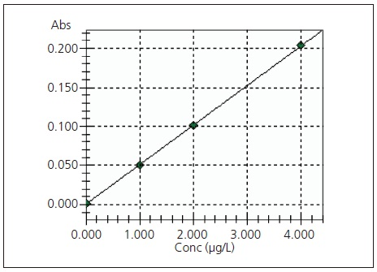

General layout of a calibration graph
  - The standard solutions should produce a straight-line graph.
  - The absorbance recorded for the sample being tested can be matched with a concentration using the graph.

- Runoff water from a copper mine is suspected of having dangerous levels of copper in it.
Before samples of the runoff water are collected, a calibration curve is created using known concentrations of copper.
These values are recorded in the table.

Measurements of absorbance
of known concentrations
of copper
Copper concentration (ppm) | Absorbance |  | Absorbance  1.2
1.0 | 0.22 |  | 1.0
2.0 | 0.45 |  | 0.8
3.0 | 0.68 |  | 0.6
4.0 | 0.90 |  | 0.4
5.0 | 1.12 |  | 0.2
 |  |  | 0 | 1 | 2 | 3 | 4 | 5 | 6
 |  |  | Concentration of copper (ppm)

Complete a graph for this data.

Samples of runoff water were taken at two locations. Their absorbances were 0.75 and 0.30. If more than 5 ppm of copper are considered unsafe, are these levels acceptable?

NC 1.9 p127-9
EC 2.10 p18-9
NC p6-8

The structure of the periodic table is based on the atomic number and the properties of the elements.

THE PERIODIC TABLE
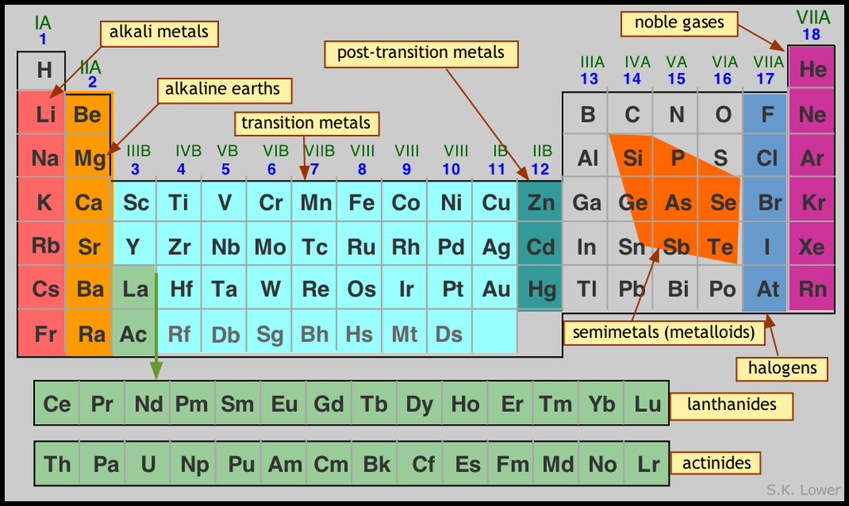
- Elements in the periodic table are listed in order of increasing atomic number but in such a manner as to created vertical groups with similar chemical properties.

- Elements are arranged in order of increasing atomic number.

- The horizontal rows of the periodic table are called periods and the vertical lists are called groups.

Periods (horizontal rows)

- The horizontal rows of the periodic table are called periods. Elements contained in:
  - the first period are H and He
  - the second period contains eight elements - Li, Be, B, C, N, O, F, Ne

- There is a steady change in the properties of elements across the period. For example, in the 3rd period there is a decrease in the metallic properties of the elements.
- Other changes that occur include:
  - reactivity.
  - Ionisation energy.

Groups (vertical columns)

- The vertical columns in the periodic table are called groups.
- The ten columns in the middle of the periodic table are called the transition elements.
- The groups contain elements with similar chemical properties, generally with a gradual change in physical properties.
- Chemical properties in each group are similar due to similar electron configrations.
  - Each element in Group 1 has 1 e⁻ in its outer shell – very reactive (alkali metals).
  - Elements in Group 2 have 2 outer shell reactive, but less than Group 1 (alkali earth metals).
  - Elements in Group 17 have 7 electrons in their outer shell – very reactive (halogens).
  - Elements in Group 18 have 2 or 8 electrons in their outer shell. This is very stable and these elements are very inert (noble gases).

EC 7.1, 7.2 p47

Questions: 7 Answers p 42
- The rows in the periodic table are called
- The columns in the periodic table are called
- Group I elements are known as the
- Do reactivity increase up or down the group?
- Sodium and Potassium are group I elements and are always stored under paraffin oil? Why?

- Give two physical properties of Group I elements.

- Give two chemical properties of Group I elements.

- Group II elements are known as the
- Group II elements are similar to group I elements. Are they more or less reactive?
- Are Group I and II elements metals or non-metals?
- Group XVII elements are known as the
- Group XVII elements will react with Group I and II elements forming compounds and with non-metal groups to form compounds.
- Does reactivity increase down or up the group?
- Group XVIII elements are known as the
- What is notable about the Group XVIII elements?

METALS AND NON-METALS
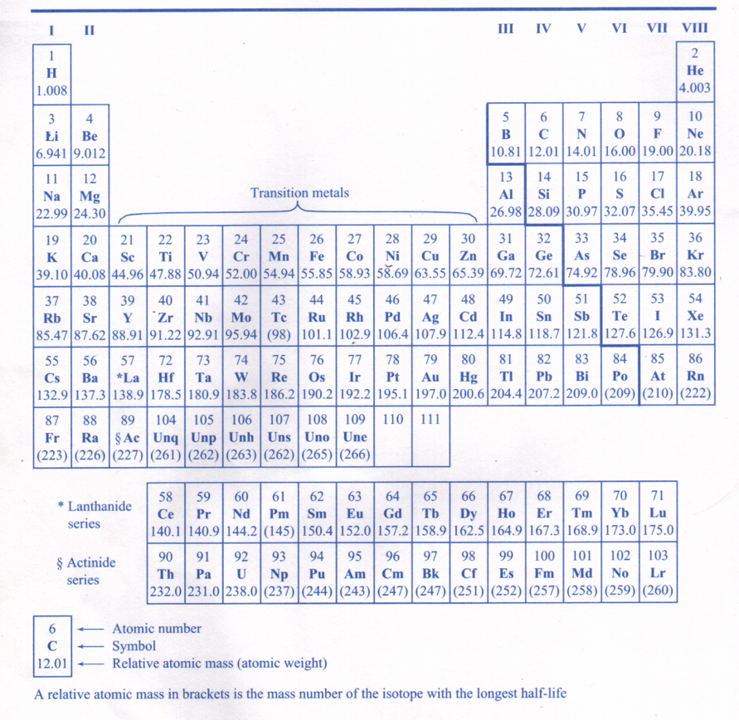
- Elements to the left and below the diagonal line are metals.
- Elements to the right and above the diagonal are line non-metals.
- Semi-metals (metalloids) are elements which are difficult to classify as metals or non-metals: boron (B), silicon (Si), germanium (Ge), arsenic (As), antimony (Sb) and tellurium (Te).
- The semi-metals located, on the period table, along the diagonal line separating the metals from the non-metals.

Metals | Non Metals
Relatively high melting solids at normal temperatures. (except Hg, Cs, Ga) | Relatively low melting points and boiling points - usually gases. (except Br₂ _{(l)}, S₈ _{(s)}, P₄ _{(s)}, I₂ _{(s)})
Usually hard | Solids, soft or brittle.
Good conductors of heat and electricity. | Poor or non conductors (except graphite)
Malleable and ductile | Brittle
Relatively high density | Relatively low density
Form positive ions | Tend to form negative ions, or molecules.
Form basic oxides and hydroxides | Form acidic oxides

PROBLEM SET: 8 Answers p 42
1. In the following list of elements, Ag, Al, Br, Ca, Cl, Cu, F, Fe, Na, Ne, S identify those which are:
• elements in group seventeen, the halogens
• elements in the third period,
• transition elements.
2. From the periodic table, classify as metals or non-metals the elements, Li, Zn, Se, Ce, Br and Xe.
Metals: non-metals
3. Which of the following elements would show the greatest similarity in chemical and physical properties? Ca, Na, Al, Ba, Cl, C

4. The radioactive isotope, technetium-99 (), is widely used in medical diagnosis and treatment. Identify the number of protons, neutrons and electrons in an electrically neutral atom of this period 5 element.

- From the information in the table,
- identify those species which are (i) isotopes, (ii) neutral atoms, (iii) positive ions, (iv) negative ions.
- Use a periodic table to identify each of the elements
- Write the actual symbol, and charge if appropriate of each of the species.

Species | Protons | Neutrons | Electrons | Answer to (a) | Answer to (b) | Answer to (c)
A | 20 | 20 | 18
B | 17 | 20 | 18
C | 20 | 22 | 20
D | 20 | 26 | 18
E | 19 | 20 | 18
F | 18 | 22 | 18

- Complete the table below:
Symbol
Protons |  |  |  | 17
Neutrons |  |  | 12 | 20 | 5
Electrons |  |  |  | 18
Net charge | 0 | 2 | 1+
Atomic Number |  |  | 11
Mass number |  |  | 23

- In the periodic table below identify:
- a noble gas;
- an alkali metal
- a halogen or group 17 element
- a transition metal;
- a metal which is not an alkali metal nor a transition metal;
- three elements which might be expected to show some similarities in properties;

 |  |  |  |  |  |  |  |  |  |  |  |  |  |  |  |  | h
a | b |  |  |  |  |  |  |  |  |  |  |  |  |  |  | g
 | c |  |  |  | e
 | d |  |  |  |  |  |  |  |  |  |  | f

NC 1.4 p111-2
NC QS 1.3 p112

TRENDS IN THE PERIODIC TABLE
The elements of the periodic table show trends across periods and down main groups, including in atomic radii, valencies, 1st ionisation energy and electronegativity as exemplified by groups 1, 2, 13–18 and period 3.

Valency

- The number of electrons in the outer (valence) shell is named valence electrons eg. sodium has 1 valence electron and oxygen has 6.
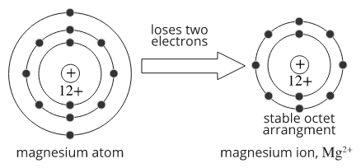

A magnesium atom will lose two electrons to form an outer shell containing 8 electrons (an octet). Magnesium therefore has a valency of 2.

EC 9.5 p71

Trends in Atomic Radius
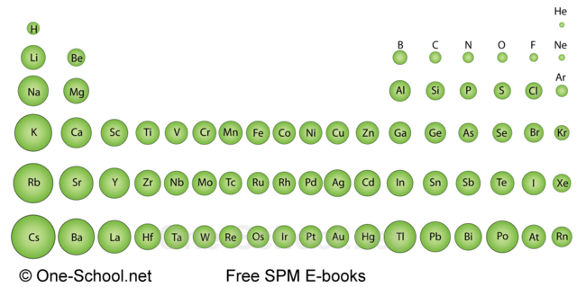
- Atomic radius is the distance from the nucleus to the outside boundary of the cloud of electrons (valence electrons) surrounding it.
- Moving from left to right, across periodic table there is a decrease in atomic radius.
  - Reason: The positive charge of the nucleus increases because of increasing protons in the nucleus. The increasing positive charge of the nucleus attracts the electrons closer to the nucleus with stronger electrostatic forces and therefore the radius decreases.

- Moving down the periodic table there is a general increase in atomic radius.
  - Reason: There are more energy levels to hold the electrons as you move down a group. With more energy levels, the distance between the protons and the electrons increases and the electrostatic force of attraction decreases. Therefore the atomic radius increases. The energy levels in between the nucleus and valence electrons also have a shielding effect and cause the electrostatic forces to have less influence.

- The graph shows the atomic radii of the first twenty elements.
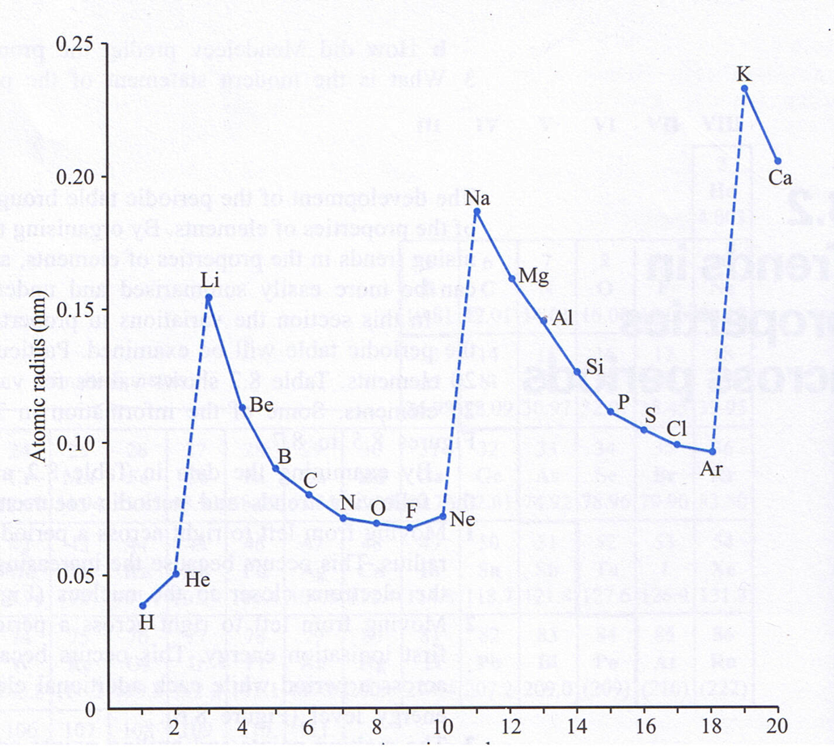

EC 9.1, 9.2 p70

HINT: If you explain any Trend in the Periodic Table, always address these five points:
      - State the definition
      - Amount of protons
      - Amount of electrons and energy levels
      - Electrostatic forces involved
      - Link force to trend

Trends in First Ionisation Energy

- Ionisation energy - the amount of energy required to remove the most loosely bound electron from one mole of neutral atoms in the gaseous state.
- The energy required to remove the first electron from an atom is called the first ionisation energy e.g. 502 kJ mol⁻¹ which represents the energy per mole needed for the process.
- The first ionisation energy of the elements generally increases from left to right across a period reaching a maximum at the noble gas.
  - Reason: As you go across the period from left to right, the amount of protons in the nucleus increases. Even if the electrons increase as well, they stay in the same energy level, so the distance between the nucleus and the electrons remain approximately the same. Because there are more protons to the right, the electrostatic force of attraction becomes stronger. This makes it harder to remove the electron, so more energy is required and ionisation energy increases.

- Ionisation energy decreases down a group.
  - Reason: Down a group, the protons and the electrons increases, but the valence electrons in their energy level are further from the nucleus. The electrostatic force of attraction becomes weaker so the electrons are less strongly bound to the positive nucleus. It takes less energy to remove the electrons from the atom and therefore the ionisation energy decreases. Other electrons shield the outer electrons from the nuclear charge, so as the nuclear charge increases (due to increasing amount of protons) the electrons shielding the outermost electron from the nuclear charge also increases and cause the electrostatic forces to have less influence.

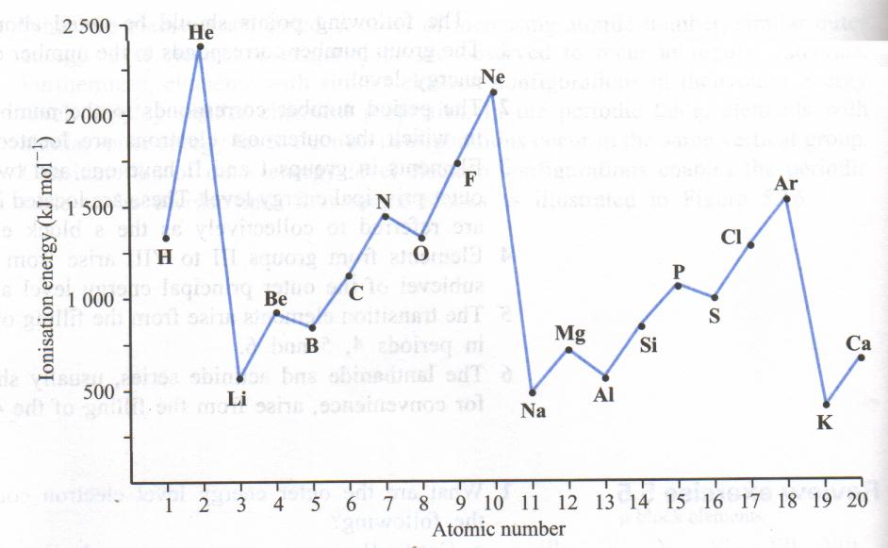

NC 9.2 p70-1

Problem Set 8 Answers p 43

1. Why is energy needed to remove an electron from an atom?

2. Which of Silicon or Phosphorous has the lowest ionisation energy? Explain.

- Consider the three elements B, C and Al. From their positions in the periodic table predict which of the three elements has the largest first ionisation energy and which the smallest first ionisation energy. Why?

- The ionisation energy is the amount of energy required to remove the most loosely bound electron from a gaseous atom. The first ionisation energy:

  - Increases or decreases across a period?
  - Increases or decreases down a group?
- Which of gold or copper has the lowest atomic radius? Explain.

Consider the information on the following graph.

What can be deducted from this graph about:

- He, Ne and Ar?

- Li, Na and K?

- the ionisation energy across a period?

- the ionisation energy down a group?

aR
Trends in Electronegativity
- Electronegativity measures the tendency for the atoms of an element to attract electrons.
- Scale between 0 and 4 used.
- Atoms of higher electronegativity have a greater tendency to attract electrons.
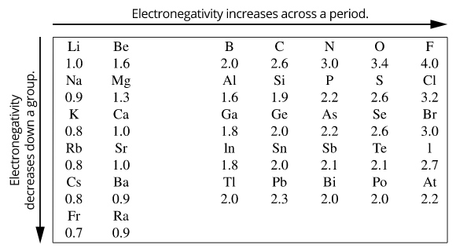
- Trends in Periodic Table
  - Electronegativity increases from left to right in a period (due to an increase in nuclear charge) and
  - Decreases down a group (size of the atoms increases and attractive force of the shielded nucleus is diminished).
- Elements on top right-hand side of period table have highest electronegativities, with fluorine being highest on 4.0.
- Elements on bottom left-hand side of period table have lowest electronegativities e.g. francium is 0.7.

EC 9.4 p71
Question: 9 Answers p 44
Rank the following elements in order of electronegativity. Give a reason for your ranking.

N, O, C: lowest to highest | Reason
O, S, Se: lowest to highest | Reason
Ca, K, Ga: lowest to highest | Reason

Trends in Electron Affinity
- Electron Affinity is the ability of an atom in the gaseous state to accept an electron and form a negative ion. It is different from electronegativity because it involves full addition of an electron.
- Electron affinity increases across a period from left to right because the atomic radius decreases. The outermost energy level is closer to the nucleus and are more strongly attracted – making it easier to add an electron.
- Electron affinity decreases down a group because the atomic radius increases. There are more energy levels and the outermost energy level is further from the nucleus. The electrostatic attraction is weaker making it more difficult to add an electron.

Trends in Metals and Non-metals
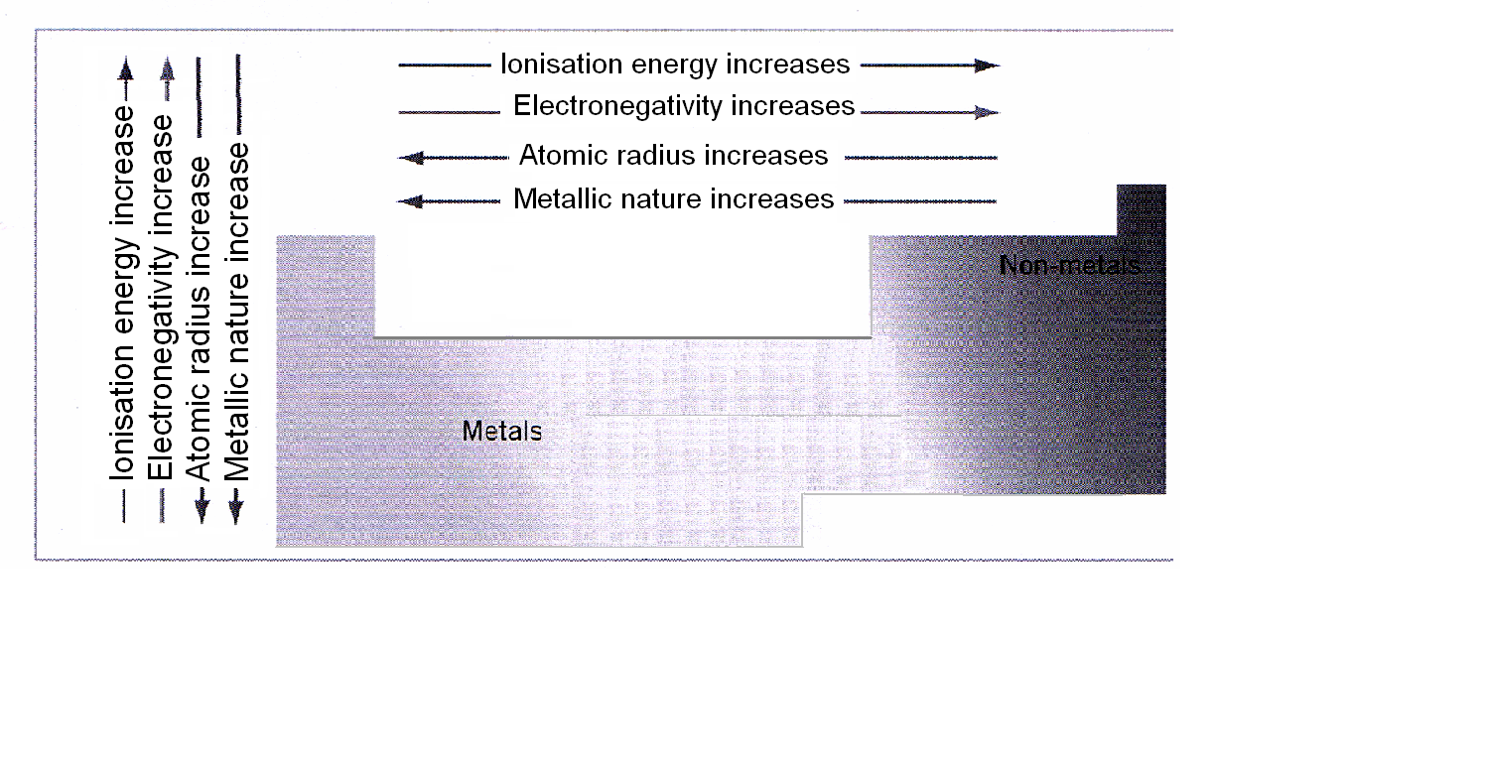
- Metals readily give up their electrons.
- Metallic nature increases down the group, example is group 14 which has non-metals at top and metals down the bottom.
- Metallic nature decreases across the period as atoms hold more strongly to their electrons. For example magnesium is less metallic than sodium and chlorine is a non-metal.

EC 9.6, 9.7 p72-3

Problem Set 10 Answers p 45

- The number of valence electrons determines the element’s valence or combining power. What is meant by valence electrons?

- Explain, in terms of atomic structure, why

- Elements in group 1 increase in reactivity as you go down the group.

- Elements in group 17 become less active as you go down the group.

- Using sodium, electron configuration 2,8,1, as an example describe and explain the relationship between the number of valence electrons and
- Bonding capacity
- Position on the periodic table
- Physical Properties

- Chemical Properties

- Repeat question 6 but this time with fluorine, electron configuration 2,7

- Bonding capacity
- Position on the periodic table
- Physical Properties

- Chemical Properties

NC 1.7 p119-22
NC QS 1.5 p122

Questions

- Representing elements – fill in the gaps.
Name | Nuclide | Electron configuration | No. of valance electrons | Metal or non-metal
Carbon -12 |  | 2, 4 | 4 | non-metal
Sodium-24
Phosphorus-31 |  | 2, 8, 5
Lithium-7 |  |  | 1
Chlorine-35
 |  | 2, 8, 6 | 6 | non-metal
Argon-40 |  |  |  | non-metal

- Give the name and symbol of the element that fits each description.
- Found in the second period of the P.T. and most reactive metal.
- Has 3 electrons in outermost shell and is a non-metal.
- Has 3 electrons in outermost shell and is a metal with lowest mass number.
- Has 14 neutrons in a stable isotope and is a metal.
- Which of the elements having atomic numbers 6, 12, 18, and 24 are non-metals?

- Which element has 47 protons and 61 neutrons and is uncharged?
- Which element has 30 neutrons and 25 protons and is uncharged?
- Found in the third row and has 6 electrons in the outermost shell.

- The element Sulfur has 4 isotopes; , , , . Explain how these isotopes differ and how they are the same.

- When Chemists talk of electrons being the ground state what do they mean?

- Name two other elements with similar chemical properties as Silicon.

- Which element has electrons in the first 3 shells and just 5 electrons in the outermost shell?

- There’s an isotope of Calcium which has a mass number of 43. Write its symbol in the style as seen in question 6.

- Name the elements which have these electronic configurations
- 2,8,3
- 2,5
- 2,8,8,1
Alongside the above elements state on the line whether the element is a metal or non-metal.

1ACHE: How Much Do You Know.

Multichoice Section:

- A magnesium ion, Mg²⁺, may have which one of the following combinations of particles?
- 10 electrons, 12 protons and 14 neutrons
- 10 electrons, 14 protons and 12 neutrons
- 12 electrons, 10 protons and 10 neutrons
- 12 electrons, 12 proton and 12 neutrons

- The atomic number of an atom is defined as
- the mass number minus the number of protons
- the number of protons in the nucleus
- the total number of particles in the nucleus
- the number of number of electrons surrounding the nucleus

- The mass number is defined as
- the mass number minus the number of protons
- the number of protons in the nucleus
- the total number of particles in the nucleus
- the number of number of electrons surrounding the nucleus

- How many valence electrons do element in group III of the periodic table have?
- 2
- 3
- 6
- 7

- The electron configuration for the magnesium ion is
- 2,8
- 2,8,2
- 2,8,4
- 2,10

- When a sodium atom reacts, which of the following occurs?
- It loses one electron to become stable
- It gains on electron to become stable
- It shares electrons to become stable
- None of the above

- Isotopes can be defined as atoms of the same type, but difference in the
- number of protons
- number of electrons
- number of neutrons
- valency

- Which of the following species have noble gas electron configuration?
      - Fe (iv) S²⁻
      - Na⁺ (v) Ne
      - Cl⁻ (vi) B

- (i) and (iii) only
- (ii), (ii) and (vi) only
- (iii), (iv) and (v) only
- (ii), (iii), (iv) and (v) only

- Which of the following is FALSE?
- Most of the mass of an atom is concentrated in its nucleus.
- All atoms having the same nuclear charge are atoms of the same element.
- All atoms having the same number of neutrons are atoms of the same element.
- An atom can gain or lose electrons without altering its nuclear charge.

NC p136-8 Chapter Review

PROBLEM SET : 1

- What is the difference between the atomic number and mass number of an atom?
Atomic number – number of protons in atom
Mass number – mass of protons and neutrons
- Give the mass number and atomic number of the following isotopes. (Use your periodic table.)
a. nitrogen-14, Z = 7; A = 14
b. iodine-127, Z = 53; A = 127
c. sodium-23, Z = 11; A = 23
d. argon-40, Z = 18; A = 40
3. Determine the number of protons, neutrons and electrons contained in one atom of the following:
a. lithium-7, p = 3 n = 4 e = 3
b. chlorine-35, p = 17 n = 18 e = 17
c. carbon-12, p = 6 n = 6 e = 6
d. chromium-52, p = 24 n = 28 e = 24
4. Use standard notation to write the symbol for neutral isotopes of atoms having a composition shown in the table below:
Isotope | A | B | C | D
Number of Protons | 2 | 84 | 32 | 9
Number of Neutrons | 2 | 125 | 40 | 10
Standard Notation | $${}_{2}^{4}{He}$$ | $${}_{84}^{209}{Po}$$ | $${}_{32}^{72}{Ge}$$ | $${}_{9}^{19}F$$
5. Complete the table for each of the ions listed:
 | A | B | C | D | E | F | G
Ion | Mg²⁺ | S²⁻ | Cl⁻ | I⁻ | N²⁻ | Fe²⁺ | Fe³⁺
Number of Protons | 12 | 16 | 17 | 53 | 7 | 26 | 26
Number of Electrons | 10 | 18 | 18 | 54 | 9 | 24 | 23

Example 1 (atom): As twice carbon, 2 x 12 = 24

Example 2 (atom): 3 helium atoms = 12 so one helium atom = 12 ÷ 3 = 4

Example 3 (isotope):
203.0 x 0.295 + 205.0 x 0.7050
= 59.885 + 144.525
= 204.41
Example 4 (isotope):
78.9 x 0.505 + 80.9 x 0.495
= 39.8445 + 40.0455
= 79.89

PROBLEM SET : 2
Helium-3; ${}_{2}^{3}{He}$ and helium-4; ${}_{2}^{4}{He}$, are two isotopes of helium. How are the isotopes similar and how are they different?

Similar – same chemical properties, same element, same atomic number (2), so same number of protons (2) and electrons (2).
Different mass number (3 and 4) so different number of neutrons(1 and 2). Different atomic masses
Naturally occurring chlorine consists of about 75% chlorine-35, which has a relative atomic mass of 35.0, and 25% chlorine-37, with a relative atomic mass of 37.0. Calculate the approximate relative atomic mass of naturally occurring chlorine.
A_{r}(Cl) = (0.75 x 35.0) + (0.25 x 37.0)
= 26.25 + 9.25
= 35.5
PROBLEM: 3
Circle the factor that will cause the ion’s path to curve more:
Low mass High mass
Low charge High charge

PROBLEM: 4 A B C

PROBLEM: 5
- What do you notice about the relative intensities of each isotope?
5 units of Cl-35, 1.6 units of Cl-37
75% Cl-35, 25% Cl-37
- Identify the isotope
90 – 50%
91 – 15%
92 – 20% 91.3 Zr - Zirconium
94 – 18%
96 – 8%
- What do you conclude?
The will was written with pen B. m/c peak at 247 with intensity of 80 000.
m/c peak of 247 and intensity of 140 000 suggests pen C.
Pen C found at the daughter’s house was used to forge the will.

Questions: 6
- What is the maximum number of electrons that can be located in the following sublevels?
2s 2 2p 6 3s 2 3p 6
- Draw the electron arrangement for (a) carbon and (b) sulphur?
①
①
①
①
①
①
①
①
①
①
①
①
①
①
①
①
S
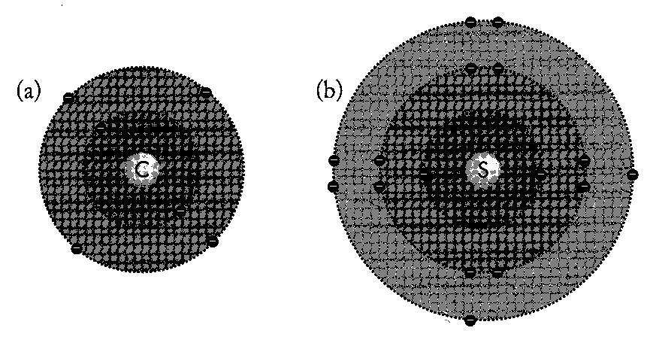
①
①
①
①
①
①
C

- Write the electron configuration (both methods) for the following:
- Helium 2 or 1s²
- Aluminium 2, 8, 3 or 1s² 2s² 2p⁶ 3s² 3p¹
- Neon 2, 8 or 1s² 2s² 2p⁶
- Nitrogen 2, 5 or 1s² 2s² 2p³
- Carbon 2, 4 or 1s² 2s² 2p²
- Potassium 2, 8, 8, 1 or 1s² 2s² 2p⁶ 3s² 3p⁶ 4s¹
- From these electron configurations identify the name, period and group of the element.
 | Electron configuration |  | Element name | Period | Group
a. | 1s² 2s²2p⁶ 3s¹ | 2,8,1 | Sodium | 3 | 1
b. | 1s² 2s²2p⁴ | 2,6 | Oxygen | 2 | 16
c. | 1s² 2s²2p⁶ 3s²3p² | 2,8,4 | Silicon | 3 | 14
d. | 1s² 2s²2p⁶ 3s²3p⁶ | 2,8,8 | Argon | 3 | 18
- Consider a neutral atom with the electron configuration 1s² 2s²2p⁶ 3s¹
- Identify the element. Sodium
- What would be its ground state electron configuration? 2,8,1
- What would happen if the atom changed its configuration from its excited state to the ground state?
To go from an excited state to the ground state, the electron must release energy in the form of a photon.

How will you use this technique to identify an unknown element?
Heat the element in a flame. Examine the light given off with a spectrometer.
Determine the spectrum given off.
Compare the spectrum to known spectra graphs to identify the element.

  - Why not?
The differences in energy levels are specific to each element.
Frequencies of light emitted by the lamp match the frequencies required by the element being tested.

Copper concentration (ppm) | Absorbance |  | Absorbance  1.2 |  |  |  |  |  | X
1.0 | 0.22 |  | 1.0 |  |  |  |  | X
2.0 | 0.45 |  | 0.8 |  |  |  | X
3.0 | 0.68 |  | 0.6 |  |  | X
4.0 | 0.90 |  | 0.4
5.0 | 1.12 |  | 0.2 |  | X
 |  |  | 0 | 1 | 2 | 3 | 4 | 5 | 6
 |  |  | Concentration of copper (ppm)
Are these levels acceptable?
0.30 1.2 ppm SAFE 0.75 3.3 ppm SAFE

Questions: 7
- The rows in the periodic table are called Periods
- The columns in the periodic table are called groups
- Group I elements are known as the Alkali metals
- Do reactivity increase up or down the group? down
- Sodium and Potassium are group I elements and are always stored under paraffin oil? Why?
Group I metals are very reactive with water and with air. As paraffin oil prevents water and air reacting metal, doesn’t react.
- Give two physical properties of Group I elements.
Soft solid low density
- Give two chemical properties of Group I elements. React with air (oxygen) to form oxide coating on metal. React with halogens to form ionic solids. React with water forming hydroxide.
- Group II elements are known as the Alkaline Earth Metals
- Group II elements are similar to group I elements. Are they more or less reactive? less
- Are Group I and II elements metals or non-metals? metals
- Group XVII elements are known as the halogens
- Group XVII elements will react with Group I and II elements forming ionic compounds and with non-metal groups to form covalent molecular compounds.
- Does reactivity increase down or up the group? up
- Group XVIII elements are known as the Noble gases
- What is notable about the Group XVIII elements? Very unreactive

PROBLEM SET: 8
1. In the following list of elements, Ag, Al, Br, Ca, Cl, Cu, F, Fe, Na, Ne, S identify those which are:
• elements in group seventeen, the halogens F, Br, Cl
• elements in the third period, Na, Al, S, Cl
• transition elements. Ag, Cu, Fe
2. From the periodic table, classify as metals or non-metals the elements, Li, Zn, Se, Ce, Br and Xe.
Metals: Li, Zn, Ce non-metals Se, Br, Xe
3. Which of the following elements would show the greatest similarity in chemical and physical properties? Ca, Na, Al, Ba, Cl, C
Ca and Ba – in same group (II) so most similar in properties as groups are most alike.

4. The radioactive isotope, technetium-99 (), is widely used in medical diagnosis and treatment. Identify the number of protons, neutrons and electrons in an electrically neutral atom of this period 5 element.

p = 43; n = 56; e = 43
- From the information in the table,
- identify those species which are (i) isotopes, (ii) neutral atoms, (iii) positive ions, (iv) negative ions.
- Use a periodic table to identify each of the elements
- Write the actual symbol, and charge if appropriate of each of the species.

Species | Protons | Neutrons | Electrons | Answer to (a) | Answer to (b) | Answer to (c)
A | 20 | 20 | 18 | Isotope, positive ion | Ca | Ca²⁺
B | 17 | 20 | 18 | Negative ion | Cl | Cl⁻
C | 20 | 22 | 20 | Isotope, neutral | Ca | Ca
D | 20 | 26 | 18 | Isotope positive ion | Ca | Ca²⁺
E | 19 | 20 | 18 | Positive ion | K | K⁺
F | 18 | 22 | 18 | Neutral | Ar | Ar

- Complete the table below:
Symbol
Protons | 8 | 8 | 11 | 17 | 4
Neutrons | 10 | 9 | 12 | 20 | 5
Electrons | 8 | 10 | 10 | 18 | 2
Net charge | 0 | 2- | 1+ | 1- | 2+
Atomic Number | 8 | 8 | 11 | 17 | 4
Mass number | 18 | 17 | 23 | 37 | 9

- In the periodic table below identify:
- a noble gas; h
- an alkali metal a
- a halogen or group 17 element g
- a transition metal; e
- a metal which is not an alkali metal nor a transition metal; b, c, d or f
- three elements which might be expected to show some similarities in properties; b, c, d

Problem Set 8
1. Why is energy needed to remove an electron from an atom?
Negatively charged electron needs energy to remove it from positively charged nucleus due to the strong electrostatic force of attraction.
2. Which of Silicon or Phosphorous has the lowest ionisation energy? Explain.
Silicon.
Ionisation energy is the amount of energy required to remove the most loosely bound electron from one mole of neutral atoms in the gaseous state.
- Silicon has one less proton (14) than Phosphorous (15).
- Both these elements electrons are in the same energy level.
- This result in a smaller electrostatic attraction for electrons for Silicon because it has one less proton in the nucleus and so less energy is needed to remove them from the atom.
- Therefore the ionisation energy will be lower for Silicon.
Do NOT use the term “net charge”

- Consider the three elements B, C and Al. From their positions in the periodic table predict which of the three elements has the largest first ionisation energy and which the smallest first ionisation energy. Why?
Least Al – valence electrons furthest from nucleus in principal energy level 3 so less attraction and less energy needed to remove electron (B and C have electrons in energy level 2 – closer to nucleus). Most is C – electrons closer to nucleus and more valance electrons than B so more energy needed to remove so more energy needed

- The ionisation energy is the amount of energy required to remove the most loosely bound electron from a gaseous atom. The first ionisation energy:
  - Increases or decreases across a period? increase
  - Increases or decreases down a group? decrease
- Which of gold or copper has the lowest atomic radius? Explain.
Copper
Atomic radius is the distance from the nucleus to the outside boundary of the cloud of electrons (valence electrons) surrounding it.
- Copper has fifty less protons (29) than Gold (79).
- Copper’s electrons will occupy 4 energy levels where as gold will occupy 6 energy levels. The valence electrons of copper will be closer to its positive nucleus than gold.
- This result in a larger electrostatic attraction for electrons for Copper because of the electrons being closer.
- Therefore the atomic radius will be smaller for copper.

Consider the information on the following graph.

- He, Ne and Ar?
These noble gases have the highest ionisation energies indicating their stable electron configurations.
- Li, Na and K?
These alkali metals of group 1 require the least amount of energy to remove an electron because they only have one electron in their outer shell.
- the ionisation energy across a period?
The ionisation energy across a period increases because the amount of protons increases across a period while the valence shell stays the same. This increases the attractive force between the nucleus and the electrons.
- the ionisation energy down a group?
There is a decrease in ionisation energy down a group because the outer electrons are further from the nucleus as atomic number increase. Although the charge of the nucleus increases, the number of electrons shielding the outer electrons from the nuclear charge also increases.

Question: 9
Rank the following elements in order of electronegativity. Give a reason for your ranking.

N, O, C: lowest to highest  C, N, O | Reason The atomic radius decreases from left to right across a period because there are more protons and the electrons are in the same energy levels. The force of attraction from the nucleus to another electron becomes larger to the right.
O, S, Se: lowest to highest  Se, S, O | Reason The atomic radius increases down a group because of more energy levels. The force of attraction from the nucleus to another electron becomes lower down the group.
Ca, K, Ga: lowest to highest  K, Ca, Ga | Reason Atoms to the right needs fewer electrons to become a noble gas configuration.

Problem Set 10
- The number of valence electrons determines the element’s valence or combining power. What is meant by valence electrons? Electrons in the outer shell of an atom. These are the ones that are involved in chemical reaction.
- Explain, in terms of atomic structure, why
- Elements in group 1 increase in reactivity as you go down the group.
Due to atomic radius. Increases as you go down so negative valence electron is further away from positive nucleus and therefore feels less attraction and is much easier to remove so more reactive. Also ionisation energy is less.
- Elements in group 17 become less active as you go down the group.
Electronegativity decreases down group as valence electrons become further away from nucleus. Fluorine small atom so valence shell of fluorine closest to nucleus and has strongest attraction for electrons. As atomic radius increases, less electron attraction.
- Using sodium, electron configuration 2,8,1, as an example describe and explain the relationship between the number of valence electrons and
- Bonding capacity can form metallic bonds with itself and ionic bonds
- Position on the periodic table group 1 or extreme left in period 3
- Physical Properties alkali metal so has properties of metals e.g. shiny lustre, high melting and boiling point, good conductor of heat and electricity
- Chemical Properties group 1 have only one valence electrons so highly reactive. Ions strongly attract negatively charged ions forming strong ionic bonds.
- Repeat question 6 but this time with fluorine, electron configuration 2,7
  - Bonding capacity gains electron to form ionic bonds or shares to form covalent bonds
  - Position on the periodic table Group 17 or right side of periodic table in period 2
  - Physical Properties halogen and non-metal so low melting and boiling points, poor conductor of heat and electricity, not ductile or malleable, gas at room temperature.
  - Chemical Properties most chemically active member of group 17, easily gains 1 electron to form negative ion, strongly attracted to positive ions to form ionic compounds

Questions

- Representing elements – fill in the gaps.
Name | Nuclide | Electron configuration | No. of valance electrons | Metal or non-metal
Carbon -12 |  | 2, 4 | 4 | non-metal
Sodium-24 |  | 2, 8, 1 | 1 | metal
Phosphorus-31 |  | 2, 8, 5 | 5 | non-metal
Lithium-7 |  | 2, 1 | 1 | metal
Chlorine-35 |  | 2, 8, 7 | 7 | non-metal
Sulfur-32 |  | 2, 8, 6 | 6 | non-metal
Argon-40 |  | 2, 8, 8 | 8 | non-metal

- Give the name and symbol of the element that fits each description.
- Found in the second period of the P.T. and most reactive metal. Lithium Li
- Has 3 electrons in outermost shell and is a non-metal. Boron B
- Has 3 electrons in outermost shell and is a metal with lowest mass number. Aluminium Al
- Has 14 neutrons in a stable isotope and is a metal. Aluminium Al
- Which of the elements having atomic numbers 6, 12, 18, and 24 are non-metals?
Carbon C Argon Ar
- Which element has 47 protons and 61 neutrons and is uncharged? Silver Ag
- Which element has 30 neutrons and 25 protons and is uncharged? Manganese Mn
- Found in the third row and has 6 electrons in the outermost shell. Sulfur S

- The element Sulfur has 4 isotopes; , , , . Explain how these isotopes differ and how they are the same.

Same number of protons (atomic number) different number of neutrons (mass number).
Similar physical and chemical properties.

- When Chemists talk of electrons being the ground state what do they mean?

e⁻‘s are in orbits with the lowest energy – closest to the nucleus.

- Name two other elements with similar chemical properties as Silicon.

Carbon, germanium, tin, lead.

- Which element has electrons in the first 3 shells and just 5 electrons in the outermost shell?

Phosphorus

- There’s an isotope of Calcium which has a mass number of 43. Write its symbol in the style as seen in question 6.

- Name the elements which have these electronic configurations
- 2,8,3 Aluminium Al Metal
- 2,5 Nitrogen N Non-metal
- 2,8,8,1 Potassium K Metal
Alongside the above elements state on the line whether the element is a metal or non-metal.

1ACHE: How Much Do You Know.

Multichoice Section:

- A magnesium ion, Mg²⁺, may have which one of the following combinations of particles?
- 10 electrons, 12 protons and 14 neutrons
- 10 electrons, 14 protons and 12 neutrons
- 12 electrons, 10 protons and 10 neutrons
- 12 electrons, 12 proton and 12 neutrons

- The atomic number of an atom is defined as
- the mass number minus the number of protons
- the number of protons in the nucleus
- the total number of particles in the nucleus
- the number of number of electrons surrounding the nucleus

- The mass number is defined as
- the mass number minus the number of protons
- the number of protons in the nucleus
- the total number of particles in the nucleus
- the number of number of electrons surrounding the nucleus

- How many valence electrons do element in group III of the periodic table have?
- 2
- 3
- 6
- 7

- The electron configuration for the magnesium ion is
- 2,8
- 2,8,2
- 2,8,4
- 2,10

- When a sodium atom reacts, which of the following occurs?
- It loses one electron to become stable
- It gains on electron to become stable
- It shares electrons to become stable
- None of the above

- Isotopes can be defined as atoms of the same type, but difference in the
- number of protons
- number of electrons
- number of neutrons
- valency

- Which of the following species have noble gas electron configuration?
      - Fe (iv) S²⁻
      - Na⁺ (v) Ne
      - Cl⁻ (vi) B

- (i) and (iii) only
- (ii), (ii) and (vi) only
- (iii), (iv) and (v) only
- (ii), (iii), (iv) and (v) only

- Which of the following is FALSE?
- Most of the mass of an atom is concentrated in its nucleus.
- All atoms having the same nuclear charge are atoms of the same element.
- All atoms having the same number of neutrons are atoms of the same element.
- An atom can gain or lose electrons without altering its nuclear charge.

